FPT University
Department of Artificial Intelligence

Multi-Camera Fall Detection System on
Edge Device with VLM Verification

Hoang Anh Dung
Nguyen Quang Khanh
Nguyen Tan Dung
Supervisor: Dr. Bui Van Hieu

© FPT University 2026. All rights reserved

ACKNOWLEDGE
We would like to express our deepest gratitude to our mentor, Mr. Bui Van Hieu, for his invaluable guidance, patience, and continuous support throughout the development of this project. His professional expertise and encouragement not only helped us navigate numerous challenges during the implementation process but also inspired us to adopt a more rigorous and critical approach to our work.
We would also like to extend our sincere appreciation to the Department of Information Technology at FPT University for providing the necessary facilities, resources, and academic environment that made this project possible.
Equally important to us is the unwavering support of our families, who have stood by us throughout this journey—offering steadfast encouragement during times of uncertainty and hardship. Their patience, motivation, and belief in us provided the strength to bring this project to completion.
Finally, we are genuinely grateful to everyone, whether explicitly mentioned or not, who contributed to the success of this capstone project.

ABSTRACT
Falls are the leading cause of injury and mortality among elderly individuals living alone, with an estimated 684,000 fatal falls occurring globally each year and 28–42% of adults aged 65+ falling at least once annually. Automatic fall detection via surveillance cameras is thus of high practical value. Although the field has reached research maturity—433 computer-vision fall-detection studies were surveyed through 2025—most existing systems rely on a single camera, which inherently suffers from blind spots and occlusion. Multi-camera setups mitigate occlusion but introduce three technical challenges that remain unresolved on resource-constrained edge hardware: (Re-Identification) loss of consistent identity as a person moves across non-overlapping camera views; (Identity Association) redundant identity assignment when two cameras concurrently observe the same subject in an overlapping zone; and (Boundary Feature Fusion) missed fall detections caused by partial occlusion at camera boundaries.
This project proposes an edge–cloud architecture on an NVIDIA Jetson Nano. Identity Association is resolved via a training-free homography projection that matches identities on a real-world floor plane. Boundary Feature Fusion is addressed by a training-free, geometry-guided fusion step within a shared Secondary Inference Engine (SGIE)—a plain YOLOv8n-cls backbone, trained with Focal Loss—which enriches each camera's features with the other's, weighted by Gaussian proximity to the epipolar line derived from floor-plane homography. Re-Identification is handled by an independent OSNet x0.25 distill model, decoupled from the shared SGIE backbone and trained via Teacher Assistant knowledge distillation from an OSNet x1.0 teacher through an OSNet x0.5 teacher assistant. All candidate fall events are further verified by a Vision-Language Model (VLM) before alerting, to suppress false alarms. Three existing baselines (PIFR and two open-source systems) were reimplemented for multi-camera deployment and benchmarked on our custom PFDD-Test dataset under identical Jetson hardware conditions.

Keyword: Fall Detection, Multi-Camera Systems, Edge-Cloud Architecture, Person Re-Identification, Homography Projection, NVIDIA Jetson Nano.
CONTENT

ACKNOWLEDGE 1
ABSTRACT 2
1. INTRODUCTION 6
1.1 Background & Motivation 6
1.2. Contributions 9
2.RELATED WORKS 10
2.1. Re-Identification under Camera Handoff 10
2.2. Identity Association 13
2.3. Multi-View Feature Fusion for Fall Posture Classification 14
2.4. Summary of Research Gaps 15
3. METHODOLOGY 17
3.1. Overall Architecture 17
3.2. Per-Camera Detection and Tracking 19
3.3. Solution for Re-Identification under Camera Handoff 20
3.4. Solution for Identity Association 24
3.5. Boundary Feature Fusion 27
3.6. Task Heads and Loss Functions 29
4. SYSTEM IMPLEMENTATION AND DEPLOYMENT 31
4.1. Edge Pipeline Implementation on Jetson Nano 31
4.2. Cloud-Based Verification and Alert Delivery 35
5. DATASET AND EVALUATION METRICS 37
5.1. Dataset and Exploratory Data Analysis 37
5.2. Evaluation Metrics 44
6. EXPERIMENTAL RESULTS AND DISCUSSION 45
6.1. Implementation Details 45
6.2. Baseline 47
6.3. Results 50
6.4. Ablation Studies 54
6.5. Discussion 55
7. CONCLUSION AND FUTURE WORK 56
REFERENCES 57

LIST OF FIGURES

3.1. METHODOLOGY: Overall System Architecture 17
3.2. METHODOLOGY: Epipolar geometry between two camera views. 27
4.1. S. I & DEPLOYMENT: Cloud Backend Workflow 35
5.1. DATASET & E.M: Class Distribution of v4_split_flat Posture Dataset 38
5.2. DATASET & E.M: Dataset Breakdown for Re-ID Model Training 39
5.3. DATASET & E.M:Public Benchmark Datasets Distribution 40
5.4. DATASET & E.M: Representative 4-Angle Spatial Perspective Samples for P1 Re-ID Scenarios 41
5.5. DATASET & E.M: Dual-Camera Perspective at Calibration Grid Vertex in Overlap Zone 42
5.6. DATASET & E.M: Dual-Camera Synchronized Samples Across Boundary Fall Scenarios for Boundary Fusion 44
6.1. E.R AND DISCUSSION: Espinosa reconstruction: accuracy from the original paper's dataset 50
6.2. E.R AND DISCUSSION: Gallery-matching similarity per case: Shared Backbone vs. OSNet x0.25 51
6.3. E.R AND DISCUSSION: Identity Association vs Geometry-only and GNN-CCA full 52
6.4. E.R AND DISCUSSION: Boundary Feature Fusion vs. Espinosa 53
6.5. E.R AND DISCUSSION: Sigma selection: average fused-classification confidence vs proxy data 55

LIST OF TABLES

6.1. E.R AND DISCUSSION: Key implementation parameters, by problem 47
6.2. E.R AND DISCUSSION: Shared-backbone Re-ID baseline: four training configurations on MSMT17 48
6.3. E.R AND DISCUSSION: GNN-CCA baseline,
literature-reported results on EPFL 49
6.4. E.R AND DISCUSSION: Per-stage FPS, RAM, and temperature on the Jetson Nano 54

1. INTRODUCTION
1.1 Background & Motivation
Global population aging is driving increasing demand for in-home safety monitoring for elderly individuals who live alone or with limited family care. Falls are among the most serious health risks for this group: an estimated 28–35% of adults aged 65+ and 32–42% of those over 70 fall at least once annually, with roughly 684,000 fall-related deaths occurring globally each year, over 80% in low- and middle-income countries [1]. Global Burden of Disease data further show a 182% rise in fall incidence among adults 65+ since 1990 [3], indicating a growing rather than stabilizing burden. In Vietnam, an estimated 1.5–1.9 million elderly people fall annually, with about 5% requiring hospitalization [4]—a significant figure given limited in-home care and remote monitoring infrastructure. Beyond immediate injury, an undetected fall (a "long-lie") sharply raises the risk of secondary complications such as aspiration pneumonia, dehydration, and pressure injuries, even without severe initial trauma.
Vision-based fall detection has consequently become a mature research area: a 2026 systematic mapping study synthesized 433 video-based fall detection studies through 2025, spanning Feature Engineering, Deep Learning, and Hybrid approaches [2]. Such systems are non-invasive and require no wearable device, fitting naturally into elderly routines. Most existing frameworks operate on a single camera, using pose or motion features to classify fall states, and many achieve strong accuracy on public benchmarks. However, single-camera systems share an unresolved limitation: occlusion and blind spots. When a person moves behind furniture or is partially blocked from view, the system loses the visual context needed for reliable classification, causing missed falls or false alarms on ordinary activities such as sitting or bending.
Multi-camera deployment is a natural remedy for occlusion, but it is not simply a matter of duplicating single-camera pipelines. Fusing multi-view observations of the same person — across overlapping or non-overlapping fields of view — introduces re-identification and multi-target association problems absent from single-camera systems. Current multi-camera fall detection research, which largely focuses on pose classification accuracy or backbone design, has yet to address this gap explicitly, particularly under real-time constraints on edge hardware such as the NVIDIA Jetson platform. Building on these limitations, this project formalizes three technical challenges in multi-camera fall detection for indoor environments — Re-Identification, Identity Association, and Boundary Feature Fusion — which Section 1.2 defines in detail and which anchor the remainder of this report.
Re-Identification— Re-Identification under Camera Handoff
This problem concerns maintaining correct individual identities when a person exits the field of view (FOV) of one camera and subsequently re-appears within the FOV of another, where no direct visual overlap exists between the two cameras for instantaneous matching. For example, when an elderly individual transitions from a hallway (monitored by Camera 1) into a living room (monitored by Camera 2), the system temporarily loses visual tracking during the transit through the blind zone. Upon re-emergence, the framework must accurately determine whether the subject is an existing or new identity. Existing Person Re-Identification (Re-ID) methods predominantly rely on appearance features learned from large-scale pedestrian datasets. Consequently, they require dedicated neural networks that impose non-trivial computational overhead, while their matching accuracy deteriorates under significant variations in lighting conditions and camera viewing angles typical of home environments. In practice, recent surveys on multi-camera tracking confirm that maintaining continuously tracked trajectories and consistent identity assignments across multi-camera networks remains an open research challenge [5].
Identity Association — Cross-Camera Identity Association under Overlapping FoV
When two cameras with overlapping FOVs observe the same individual simultaneously, each camera independently operates its own object tracker. Without cross-camera coordination, the system may assign two distinct tracking IDs to the same individual. This results in identity duplication, leading to overcounting or, more critically for fall detection, conflicting state estimates (e.g., Camera 1 reporting "standing" while Camera 2 reports "fallen") for a single physical event. For instance, if an individual sits in the center of a living room observed concurrently by both Camera 1 and Camera 2, an uncoordinated system registers 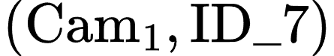 and 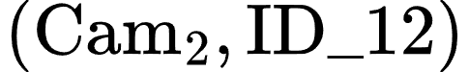 as separate entities. Research on identity assignment in overlapping camera networks confirms this as a persistent technical hurdle [6]. Certain contemporary multi-camera frameworks (such as DMMA proposed by Yang et al. [6]) deliberately avoid reliance on camera calibration to maintain flexibility for mobile cameras. However, this trade-off necessitates computing deep learning-based appearance embeddings for overlapping region matching—a task that could be executed at significantly lower computational cost using pure geometric transformation when dealing with fixed cameras, as in the smart-home surveillance setup of this project.
Boundary Feature Fusion — Multi-View Feature Fusion for Fall Classification
This scenario occurs when a fall event takes place directly at the boundary region between the FOVs of two cameras, resulting in each individual camera capturing only a partial view of the subject's body or experiencing local visual occlusion. Under such conditions, neither camera independently receives sufficient visual evidence to classify the posture as a fall with high confidence. For example, if a person falls adjacent to a dining table, their upper body may be obstructed by the tabletop in Camera 1, while Camera 2 captures the lower body but suffers head occlusion caused by surrounding chairs. If processed independently, neither single-camera pipeline yields a confidence score high enough to trigger an alarm. Partial occlusion has been shown to severely degrade the accuracy of computer vision-based fall detection models [7]. This issue was recognized early in multi-camera fall detection literature; a seminal work [8] mitigated occlusion by assuming that the fallen individual remains unobstructed in at least one camera view. That is, it selected the single "cleanest" viewpoint rather than fusing information across multiple partially occluded streams—an approach proven to fail when this optimistic assumption no longer holds [9]. Boundary Feature Fusion represents the most complex of the three challenges because it cannot be solved solely through identity matching like Re-Identification and Identity Association. Instead, it demands feature-level fusion within the model architecture when no individual camera maintains an unobstructed view—a key research gap largely unaddressed by existing multi-camera fall detection literature (which primarily focuses on multi-target tracking and identity re-identification, closely aligned with Re-Identification and Identity Association).
1.2. Contributions
To address the three technical challenges introduced above, this thesis makes four contributions.
Overall architecture. Multi-camera deployment is a natural answer to the occlusion and blind-spot limitations of single-camera fall detection, but combining multiple views on hardware modest enough for real home deployment has rarely been demonstrated end-to-end in prior work, which typically assumes either a single camera or server-grade computing resources. This thesis contributes a complete edge–cloud architecture that keeps real-time perception on a compact edge device while offloading final verification to the cloud, so that a candidate fall event is confirmed before an alert is raised — reducing false alarms without adding perceptible delay to genuine emergencies.
Re-Identification. When a resident moves between rooms covered by different, non-overlapping cameras, the system must recognize that the person reappearing is the same individual rather than treating them as new — a capability existing multi-camera fall-detection systems rarely address directly, often assuming it away by reusing whatever backbone is already available for other tasks, for the sake of saving resources on constrained hardware. This thesis examines that assumption directly and contributes a Re-Identification design chosen on the basis of controlled comparison rather than convenience, substantially improving how reliably a returning resident is correctly recognized rather than mistaken for a stranger or a different known individual.
Identity Association. When two cameras cover an overlapping area, a person visible to both must be recognized as one individual rather than counted twice, since a duplicate identity can produce conflicting fall/no-fall readings for the same event. This thesis contributes an association procedure that resolves this duplication without training any model, keeping the added computational cost on the edge device minimal while still matching people in a way that avoids the mismatches a simpler, greedy strategy would risk when several people are present at once.
Boundary Feature Fusion. A fall occurring exactly at the boundary between two cameras' fields of view leaves neither camera with a complete view of the person — the scenario existing single-camera or independently-multi-camera systems are least equipped to handle, since it cannot be resolved by identity matching alone. This thesis contributes a feature-fusion mechanism that lets an occluded camera view draw on context from the other camera before a posture decision is made, without requiring paired multi-camera training data that would have been impractical to collect within the project's timeline.

2.RELATED WORKS

2.1. Re-Identification under Camera Handoff
The Re-Identification problem corresponds to a long-standing challenge in video surveillance literature commonly referred to as camera handoff or multi-camera tracking across non-overlapping (disjoint) fields of view (FOVs). This section reviews three primary methodological paradigms established in prior literature—classical spatio-temporal inference, deep embedding-based Person Re-Identification (Re-ID), and joint detection-embedding architectures—before identifying the specific research gap addressed by this thesis.
Classical Paradigm: Spatio-Temporal Inference across Cameras. In a foundational study, Javed et al. [10] formulated camera handoff as an observation correspondence problem between subjects appearing at distinct temporal and spatial locations across camera views, without assuming camera calibration or 3D scene modeling. Their solution integrated two distinct signals: a learned Brightness Transfer Function (BTF) computed for each camera pair to compensate for color and illumination variations during appearance matching—a precursor to modern camera-invariant approaches—and a probabilistic transition time model capturing inter-camera transit durations derived from historical observations. The latter served to filter candidate matches that were visually similar but temporally implausible. However, learning reliable transition time distributions requires observing extensive historical cross-camera traversals—a condition easily met in public surveillance networks operating continuously over months, but impractical for a dual-camera home environment constrained by an eight-week deployment timeline. Consequently, this thesis adopts a fixed time window mechanism (the gallery lifespan detailed in Section 4.3) as a lightweight approximation of this principle rather than modeling full probabilistic transition distributions.
Modern Paradigm: Deep Embedding-Based Person Re-Identification. Following the introduction of large-scale pedestrian benchmarks such as Market-1501 and MARS, deep metric learning became the dominant Re-ID paradigm. Under this approach, deep neural networks project pedestrian images into an embedding space where distance directly reflects identity equivalence. Hermans et al. [11] demonstrated that Triplet Loss optimized with a batch-hard mining strategy outperforms traditional classification loss combined with separate metric learning algorithms. This formulation is adopted for the Re-ID head within our Secondary Inference Engine (SGIE) (Section 4.3).
Backbone Choice: Shared Classification Backbone vs. Dedicated Re-ID Networks. The choice of which backbone produces this embedding matters as much as the loss function used to train it. Purpose-built Re-ID architectures such as OSNet[18] are explicitly designed around instance-level discrimination: their omni-scale residual blocks and unified aggregation gates are optimized so that images of the same category (person) are pushed apart in feature space according to identity, at multiple spatial scales simultaneously. A generic classification backbone—such as the YOLOv8n-cls network already deployed as SGIE for posture classification—is optimized for the opposite objective: instances of the same posture class should map to similar features regardless of who the individual is. Reusing such a backbone for Re-ID therefore inherits the same task-conflict problem already noted for FairMOT [17] in the joint-detection setting, except here the competing objectives are posture classification and identity discrimination rather than detection and identity discrimination. This is precisely why dedicated Re-ID networks are the default choice in the wider literature rather than repurposed detection or classification backbones. An earlier design iteration explored a shared-backbone architecture between the Pose and Re-ID branches, motivated by minimizing persistent memory overhead and avoiding a system-wide FPS drop; empirical testing (Section 6.2) confirmed the task-conflict problem predicted above, so the final architecture instead runs Re-ID as a fully independent OSNet x0.25 model, decoupled from the shared backbone. Because Re-Identification is one of the three official technical contributions of this thesis — not a future-work extension — guaranteeing stable throughput for all three modules (Re-Identification under camera handoff, Identity Association, and Boundary Feature Fusion) running concurrently on the same resource-constrained device is a hard requirement rather than an optional trade-off.
Cross-Camera Domain Gap: A Persistent Challenge. Whether employing classical BTFs or modern deep embeddings, inter-camera sensor differences and illumination shifts persistently degrade cross-view feature alignment for the same individual. Xiang et al. [12] quantified this cross-camera feature drift on operational surveillance hardware, while Zhong et al. [13] demonstrated that camera-specific style variations induce domain gaps where intra-class variance frequently exceeds inter-class variance. To mitigate this bias between the project's two fixed cameras, this thesis adopts a lightweight camera-conditional normalization layer inserted immediately before the Re-ID head—a narrowed variant of style-invariant backbone normalization (IBN-Net [14]) and camera-specific batch normalization (Camera-based Batch Normalization [15]), exploiting the fact that only two fixed cameras are involved rather than an arbitrary, unseen camera population as in the original works. Full architectural details are given in Section 4.3.
Joint Detection and Re-Identification Architectures. To avoid the computational burden of executing separate detection and feature extraction pipelines, Joint Detection and Embedding (JDE) architectures attach a lightweight Re-ID branch directly to an object detector backbone, sharing feature maps during a single forward pass. JDE [16] pioneered this unified paradigm, while FairMOT [17] improved upon it using the anchor-free CenterNet detector, achieving state-of-the-art accuracy for both tasks. Crucially, FairMOT demonstrated that detection and Re-ID tasks inherently compete for network capacity when sharing a backbone. This insight validates our architectural decision: isolating the SGIE (which houses the Re-ID branch) into a standalone network that operates post-detection, rather than embedding Re-ID directly within the Primary Inference Engine (PGIE) backbone (detailed in Section 4.3).
Remaining Research Gap. Existing literature on camera handoff and cross-camera Re-ID predominantly focuses on two extremes: large-scale public surveillance networks with complex topologies requiring automated topology learning over massive observation datasets, or unconstrained pedestrian Re-ID benchmarks (e.g., Market-1501, MSMT17) evaluated without edge deployment hardware constraints. Neither extreme aligns with the operational scope of this thesis: a fixed dual-camera indoor setup with a single predefined blind zone, deployed on resource-constrained edge hardware (NVIDIA Jetson Nano 4GB) , where Re-ID serves as an auxiliary signal supporting a broader fall detection pipeline rather than a standalone objective. This work explicitly leverages these domain constraints to simplify system design—utilizing a lightweight shared embedding network instead of automated topology learning or a dedicated Re-ID backbone, and a fixed time window instead of full probabilistic transition models—as detailed in Section 4.3.

2.2. Identity Association — Cross-Camera Identity Association under Overlapping FoV
Existing literature on resolving duplicate observations of the same individual across simultaneously overlapping camera views spans a broad spectrum, ranging from training-free geometric methods to complex deep learning architectures requiring server-grade GPUs. This section examines a representative baseline at each extreme of the spectrum, alongside a lightweight hybrid framework that serves as the theoretical foundation for our design choices.

Classical Geometric Approaches
Fleuret et al. [19] proposed the Probabilistic Occupancy Map (POM), which integrates foreground silhouettes obtained via background subtraction across multiple camera views within a probabilistic framework to estimate person occupancy probabilities on a ground-plane grid via mean-field inference. This approach was later extended with dynamic programming to optimize multi-object trajectories [20]. While training-free and executable on standard CPUs, POM relies entirely on binary silhouette segmentation and lacks visual appearance modeling. Consequently, it suffers from severe degradation when multiple subjects wear visually similar clothing—a scenario highly prevalent in domestic living environments.

Modern Deep Learning Architectures
Teepe et al. [21] proposed EarlyBird, an end-to-end multi-view detection framework that projects raw feature maps from individual cameras onto a unified Bird’s-Eye-View (BEV) plane prior to object detection. By executing detection directly in the BEV space, each subject is localized exactly once, effectively eliminating the cross-camera identity matching problem by design. EarlyBird achieved state-of-the-art results on the Wildtrack dataset (82.4% IDF1, a +5.6% improvement) and 92.3% IDF1 on MultiviewX. However, as explicitly noted in the authors' limitation analysis, EarlyBird requires full camera calibration, precise frame synchronization, and substantial computational resources to process multi-stream high-resolution feature maps concurrently—a common bottleneck among deep multi-view detectors, none of which have demonstrated real-time performance on edge hardware below desktop/server GPUs.

Mid-Tier Hybrid Frameworks
Operating at a lower computational complexity, the hybrid pipeline proposed by Zhang et al. [22] aligns closely with our proposed architecture. Their system executes detection and tracking independently on each camera stream, projects single-camera trajectories onto a common ground plane via homography transformation, and resolves cross-camera identity associations using spectral clustering augmented by visual appearance and motion features. Utilizing a real-time detector (YOLOX), this method achieved an IDF1 score of 70.64%, demonstrating that lightweight, homography-centric pipelines can maintain competitive association precision without incurring massive deep learning overhead.

Identified Research Gap
In summary, existing literature remains polarized between fragile, training-free geometric methods and computationally prohibitive deep learning models. While mid-tier hybrid paradigms confirm the technical viability of lightweight homography-based matching, no existing study has evaluated such pipelines under strict edge constraints (e.g., NVIDIA Jetson Nano) or within the specific domain of automated fall detection, where cross-camera identity misassociation directly compromises alert reliability. Chapter 4 addresses this explicit research gap.

2.3. Multi-View Feature Fusion for Fall Posture Classification
When utilizing multi-camera systems for fall detection, the most prevalent information fusion strategy operates at the decision level, rather than the feature level. Ezatzadeh et al. [23] proposed a representative three-stage framework exemplifying this paradigm: each active camera independently generates a local decision regarding the presence of a fall event. A "coverage rate" coefficient, reflecting the proportion of the subject visible within that camera's field of view, is subsequently used to weight and aggregate these local decisions into a final consensus. While decision-level fusion is computationally lightweight and fault-tolerant against single-camera failures, it inherently assumes that each individual camera can render a sufficiently reliable local prediction prior to aggregation. However, when a subject falls directly at a camera boundary — such that their body is physically partitioned across the fields of view of two adjacent cameras — neither camera receives sufficient visual context to form a high-confidence local decision. Consequently, aggregating unreliable local predictions yields negligible performance gains.
Conversely, feature-level fusion guided by multi-view geometry has emerged as a powerful alternative in the adjacent field of multi-view human pose estimation, where occlusion similarly represents a central bottleneck. TransFusion [24] introduced the concept of the "epipolar field": rather than combining pre-computed prediction outputs, it aggregates intermediate CNN feature maps across neighboring camera views using a Transformer architecture. The fusion weights within this framework are spatially guided by epipolar geometry formulated as positional encodings. This mechanism enables feature representations from each viewpoint to be enriched by geometrically corresponding regions from complementary camera angles prior to generating final classifications. TransFusion demonstrated consistent accuracy improvements over prior geometry-guided fusion methods on the Human3.6M and Ski-Pose benchmark datasets while requiring only 5 million parameters — substantially more efficient than the 235-million-parameter geometry-guided fusion architecture proposed by Qiu et al. [25], which TransFusion built upon.
To the best of our knowledge, geometry-guided feature-level fusion mechanisms akin to TransFusion have neither been adapted for multi-camera fall posture classification nor evaluated under strict edge-deployment constraints. Existing multi-camera fall detection systems remain predominantly restricted to decision-level fusion, as discussed above, whereas feature-level fusion techniques remain confined to 3D pose regression on fully calibrated server-based platforms without embedded hardware validation. This explicit research gap directly motivates the cross-camera feature fusion mechanism proposed in Chapter 4 of this thesis.

2.4. Summary of Research Gaps
The preceding sections reviewed existing literature addressing each individual technical challenge — Re-Identification under camera handoff (Section 2.1), Identity Association under overlapping fields of view (Section 2.2), and boundary feature fusion for fall posture classification (Section 2.3). Synthesizing this body of work reveals three primary research gaps, each mapping directly to the technical challenges introduced earlier in this thesis.
Research Gap in Re-Identification under Camera Handoff: As analyzed in Section 2.1, literature on camera handoff and cross-camera Re-ID is polarized between two extremes. On one hand, classical spatio-temporal inference methods [10] were engineered for large-scale public surveillance networks, requiring extensive historical observation data collected over months to estimate reliable transition probability distributions — far exceeding the data accumulated from an eight-week dual-camera indoor setup. On the other hand, deep learning-based embedding approaches [11], [17], while achieving high matching precision, are evaluated exclusively on general pedestrian benchmarks (e.g., Market-1501, MSMT17) without accounting for real-time edge hardware constraints. Neither paradigm aligns with an indoor dual-camera setup operating on resource-constrained edge hardware.
Research Gap in Identity Association under Overlapping Fields of View: As discussed in Section 2.2, literature addressing identity association spans a similar continuum — from training-free geometric techniques that degrade when subjects wear similar clothing [19] to complex deep learning models that deliver superior accuracy but demand server-grade GPUs, full camera calibration, and tight inter-camera frame synchronization [21]. Even mid-tier hybrid architectures closest to our proposed system [22] remain unvalidated on edge hardware. This indicates that while lightweight, homography-centric designs are technically viable, their real-time performance on resource-constrained edge platforms remains unproven in existing literature.
Research Gap in Boundary Occlusion Fusion: The gap here is structural rather than purely algorithmic. Existing multi-camera fall detection frameworks, such as the three-stage pipeline in [23], rely predominantly on decision-level fusion — where each camera generates an independent decision prior to weighted aggregation. This paradigm inherently fails in boundary occlusion scenarios: when a subject is physically partitioned across the fields of view of adjacent cameras, neither camera independently receives sufficient visual context to render a reliable local prediction. Conversely, geometry-guided feature-level fusion [24] has proven highly effective in multi-view pose estimation but has neither been adapted for fall posture classification nor evaluated under embedded hardware constraints.
Unified Synthesis: Across all three research gaps, no existing work in the surveyed literature simultaneously resolves cross-camera re-identification, identity association, and boundary occlusion fusion under a unified, resource-constrained edge deployment setting. Most prior studies either address a single isolated problem or achieve multi-view capability at the expense of computational requirements far exceeding the capacity of low-cost edge hardware. The system proposed in Chapter 4 aims to bridge this explicit gap — not by seeking absolute accuracy superiority over specialized single-purpose models, but by demonstrating that a lightweight, training-efficient design can concurrently address all three multi-camera challenges and execute reliably on resource-constrained edge hardware (NVIDIA Jetson Nano) — a milestone that remains unachieved in prior literature.

3. METHODOLOGY
3.1. Overall Architecture
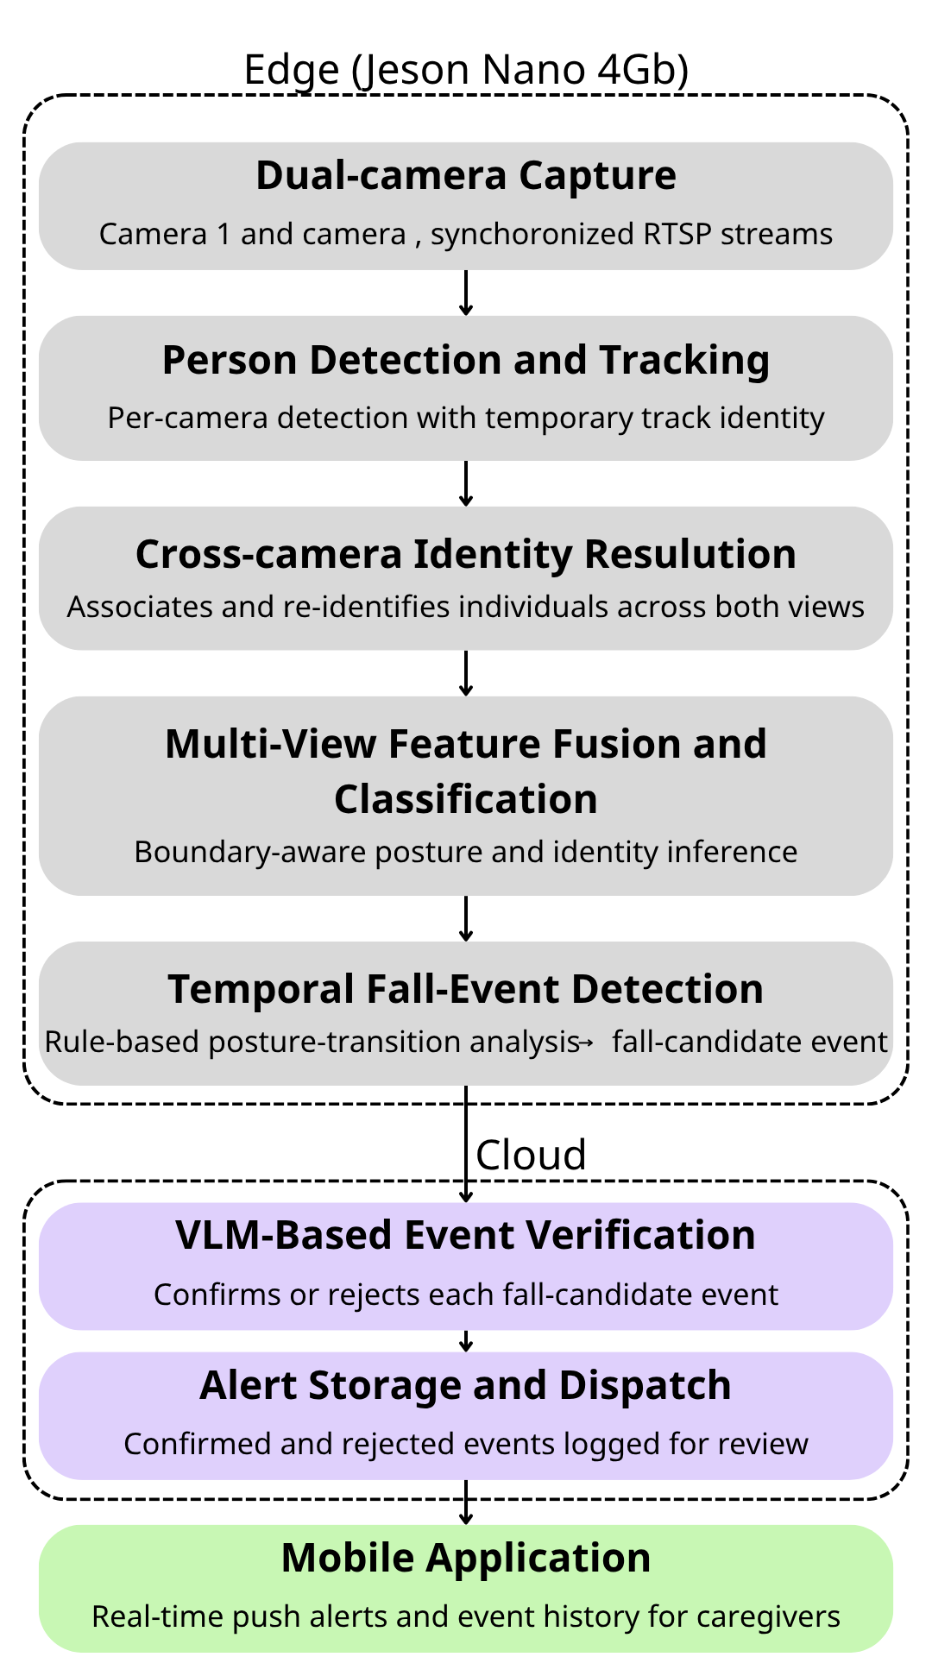
Figure 3.1 Overall System Architecture
The system is designed as a three-tier distributed architecture, reflecting the practical constraints of a home-based fall monitoring system: real-time visual processing runs locally on the edge device for low latency and network independence, while heavier verification is offloaded to the cloud. The Edge tier, deployed on an NVIDIA Jetson Nano (4GB), captures video from two cameras, detects and tracks individuals, resolves their identity across views, fuses multi-camera features for posture classification, and detects fall events through a temporal rule. The Cloud tier, running on a personal server via Docker Compose, receives events over MQTT, verifies them using the Gemini model, and persists data. The Mobile tier, built with Flutter, delivers real-time alerts and event history to caregivers.
The pipeline begins with two RTSP streams from fixed cameras positioned with partially overlapping fields of view — a deliberate placement, since it is what allows the three technical challenges introduced earlier in this thesis to arise, and to be addressed, within the same system. The streams are batched through a stream multiplexer that preserves source-camera identity per frame, a detail required for every downstream stage to later distinguish and re-associate data from the two cameras.
Person Detection and Tracking (Section 4.2) applies a YOLOv8n detector together with a multi-object tracker (NvSORT) to localize individuals and assign each a temporary, per-camera track identity. Cross-Camera Identity Resolution then determines whether observations from the two cameras, at the same moment, correspond to the same person, using a geometric association step based on floor-plane homography (Section 4.4); when only one camera observes a person at a given time — a common occurrence in a real household rather than a fully-instrumented lab — the system falls back to a single-camera path rather than stalling. Separately, a re-identification mechanism (Section 4.3) recognizes a person who has left both cameras' fields of view and later reappears, using identity embeddings rather than an instantaneous geometric match.
Multi-View Feature Fusion and Classification (Section 4.5) is the core technical contribution of this thesis. A shared feature-extraction backbone, adapted from the existing posture-classification model, processes each camera's crop; when a pair of crops is confirmed to belong to the same person, their features are combined through a cross-camera attention mechanism guided by epipolar geometry, allowing information missing in one view to be recovered from the other before any classification decision is made. The fused representation feeds two output branches (Section 4.6): a Pose Head for posture classification, and a Re-Identification Head producing the embeddings used by the mechanism above.
The resulting posture sequence — unified per person rather than per camera — feeds a State Buffer and a Temporal Rule Detector. Running this temporal analysis after fusion, rather than independently per camera, is deliberate: a fall occurring exactly at the camera boundary might otherwise never produce a valid transition on either view alone, causing a real fall to be missed. A confirmed transition generates a fall-candidate event, packaged with recent frames and published to the Cloud tier over MQTT.
Every fall-candidate event, regardless of confidence, is verified by the Gemini model against its frame sequence, distinguishing genuine falls from visually similar but harmless postures. Verification runs unconditionally rather than being gated by confidence, reflecting a priority on alert accuracy over inference cost. Confirmed events are stored and pushed to the mobile app via Firebase Cloud Messaging; rejected events are retained and labeled for later error analysis.
Sections 4.2 – 4.6 detail each component: 4.2 per-camera detection and tracking, 4.3 cross-camera re-identification, 4.4 floor-geometry identity association, 4.5 epipolar-guided feature fusion, and 4.6 the dual-branch output heads and their loss functions.
3.2. Per-Camera Detection and Tracking
The first stage of the vision pipeline converts each camera's raw video into a set of localized person crops with temporary identity assignments, forming the base data unit for all downstream processing. It runs entirely independently per camera and consists of a detector followed by a tracker.
Detection uses YOLOv8n, the smallest variant in its family, chosen given the strict compute and memory budget of the 4GB Jetson Nano, an older-generation device that must carry the full dual-camera pipeline alongside downstream inference. The model is restricted to a single class — person — filtered from the original eighty-class COCO taxonomy, reducing unnecessary computation. It is exported to ONNX and compiled into a 16-bit TensorRT engine directly on the target device, since a compiled engine is tied to the specific hardware and library version it was built on. The two streams are processed in a batch of size two, matching the number of sources exactly — a detail that directly affects whether inference results are correctly re-associated with their source camera in DeepStream's batched pipeline. The output, per frame per camera, is a set of bounding boxes with detection confidence and source-camera identity attached.
Tracking assigns a temporary identity, maintained continuously per camera, to each detected person. Tracking-by-detection methods generally follow the same cycle each frame: predict each tracked object's position via a motion model (typically a Kalman filter), match predictions against new detections by spatial overlap (typically IoU), and resolve the best assignment via an optimal algorithm (typically Hungarian) — deciding which identities persist, which are newly created, and which are terminated after several unmatched frames.
The tracker initially chosen was ByteTrack, valued in the literature for using low-confidence detections to preserve continuity through brief occlusions. During integration with the DeepStream version in use, however, it caused a memory-access fault that terminated the pipeline — a compatibility issue with that specific platform version rather than a configuration error. The thesis therefore adopted NvSORT, a tracker from the same SORT family pre-optimized within DeepStream's own libraries, restoring stability while preserving the same motion-prediction and spatial-matching principles. A lightweight, platform-native tracker is especially appropriate given the device's limited compute capacity.
The output of this stage, per camera, is a continuously updated stream of identity–bounding-box pairs and corresponding crops, feeding the classification stage that follows. One limitation is deliberately retained here: a tracking identity is valid, and persists, only within a single camera's field of view, and is lost entirely once the person leaves it. This limitation directly motivates the cross-camera re-identification problem addressed in Section 4.3.
3.3. Re-Identification under Camera Handoff
Architectural Position of the Re-Identification Solution within the Overall Pipeline
Re-Identification is handled by an independent OSNet x0.25 model, fully decoupled from the shared Secondary Inference Engine (SGIE) posture-classification backbone. The model receives raw RGB person crops directly from the Primary Inference Engine's (PGIE) detection output and maps them into a 256-dimensional, L2-normalized identity-discriminative embedding, trained via Teacher Assistant knowledge distillation (below) rather than from a branch shared with any other module. A system-level track and gallery management module compares the embedding of a newly detected subject against the most recent embeddings of recently lost tracks to decide whether to retain an existing track ID or assign a new identity. Because both the embedding and the gallery embeddings are L2-normalized, cosine similarity — the standard matching metric — reduces to a simple dot product, cheap enough to compute at scale on the edge device.
Re-Identification and Identity Association Are Fully Independent
Re-Identification and Identity Association solve related but architecturally unrelated problems and share no component. Identity Association (Section 4.4) is purely geometric — homography projection to a shared floor plane, a Euclidean cost matrix, and the Hungarian algorithm — with no learned weights and no appearance features of any kind. Re-Identification, by contrast, is entirely appearance-based, relying on the OSNet embedding described above. The two were evaluated, tuned, and are deployed independently of one another.
Decoupling Re-ID from Both the PGIE and SGIE Backbones
A prevalent paradigm in multi-object tracking is Joint Detection and Embedding (JDE), which appends a lightweight Re-ID branch directly onto the object detector backbone, sharing a single forward pass [16]. FairMOT [17] refined this using the anchor-free CenterNet detector, achieving high accuracy across both tasks. However, as the FairMOT authors demonstrate, this architecture suffers from inherent task competition: detection requires intra-class invariance, whereas Re-ID demands inter-class discriminability; without careful loss-balancing, joint optimization favors detection at the expense of Re-ID quality [17]. The same conflict was independently confirmed empirically in this project (Section 6.2): a Re-ID head sharing the SGIE posture-classification backbone collapsed to near-random accuracy, because a backbone trained to classify posture actively discards the appearance detail Re-ID depends on. For this reason, the Re-ID model is not attached to either the Primary Inference Engine (PGIE) backbone (YOLOv8n) or the SGIE posture-classification backbone; it runs as a fully independent model (OSNet x0.25). This incurs a separate forward pass on the Jetson platform, but the cost remains acceptable since it only processes cropped bounding boxes, not full frames.
Re-ID Training Objective: Teacher Assistant Knowledge Distillation
A direct single-stage distillation from an OSNet x1.0 teacher (~8.8M parameters) to the OSNet x0.25 student (~2.2M parameters) did not improve on the non-distilled baseline (Rank-1 52.00% vs. 52.44%), plausibly because the ~4x capacity gap between teacher and student is too large for the student to usefully mimic the teacher's feature space. The deployed model instead uses a two-stage distillation chain that narrows this gap to two ~2x steps.
Stage 1 trains an OSNet x0.5 Teacher Assistant (TA) from the frozen OSNet x1.0 teacher, with total loss:
Stage 2 freezes the trained TA and uses it as the new teacher to train the final OSNet x0.25 student, with total loss:
In both stages,  is Cross-Entropy identity classification loss, 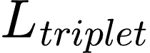 is batch-hard Triplet Loss (same formulation as Eq. 4.1 below, margin  per [11]), and  is a normalized L2 distance between student and teacher (or TA) features. Training for the final student was auto-stopped at epoch 56 once validation accuracy stopped improving; the checkpoint from epoch 46 was retained as the best result. Training labels are the track IDs assigned during PFDD annotation.
Track Management and the Re-Identification Decision Rule
When a track disappears from every active camera for more than N consecutive frames (a configurable parameter, consistent with the Temporal Transition Detector's design), it is moved into a temporary gallery G rather than discarded — each entry retaining the track's identity, most recent embedding, last observed posture, and departure timestamp. When a new track appears with embedding e_new, its identity is resolved by first finding the nearest gallery entry, then applying a distance-and-time gate:
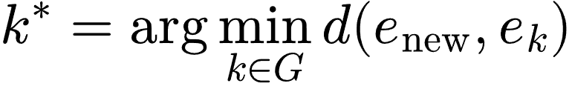
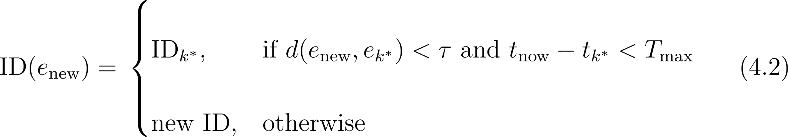
where τ is the distance threshold and T_max the gallery entry's maximum lifespan, corresponding to a plausible transit time between the two indoor cameras. This temporal constraint prevents matching against an unrelated individual who happens to appear much later.
Implementation on Edge and Cloud
Matching is not performed on individual frames but over an accumulation window: each track buffers 5–10 embedding frames (the lower bound ensures sufficient confidence, the upper bound limits latency), which are mean-pooled and L2-normalized before being published over MQTT (topic reid/query) to the cloud tier — this edge-to-cloud query architecture follows the pattern of Yen's MCDPT thesis [26]. On the cloud side, once a match is found, the gallery embedding is not overwritten but updated via an exponential moving average with update rate β, letting the gallery adapt gradually to appearance drift without discarding prior appearance information. The values currently used in the implementation are τ = 0.6 and β = 0.1 — current codebase defaults, not yet the result of experimental tuning; both will be evaluated and adjusted during the SGIE training/evaluation phase.

3.4. Identity Association

Recap of the Gap
Section 2.3 identified a gap between two extremes: geometric methods that require no training but lack any appearance model [19], and deep-learning methods that achieve high accuracy but demand full calibration, tight synchronization, and substantial hardware [27]. A middle tier explored in the literature review — lightweight graph-based matching such as GNN-CCA [28] — narrows this gap but still introduces a trainable component. The solution adopted here goes one step further: it combines a one-time floor calibration via homography with the Hungarian algorithm [29] for globally optimal cross-camera matching, requiring no training, no learned parameters, and no additional model running on the edge device — trading a measure of accuracy in extreme close-proximity scenarios (quantified in Section 6.5) for zero training cost and full compatibility with the Jetson Nano 4GB compute budget.

Architecture and Formulation
Foot-point projection via homography. For each camera c, let 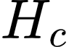 denote its calibrated  homography matrix. Given a bounding box 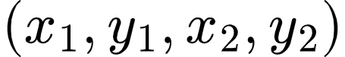, the foot point is defined as:
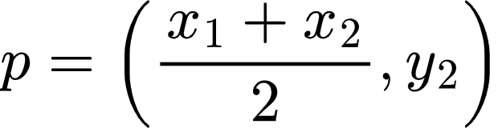
This point is projected onto the shared ground plane as:
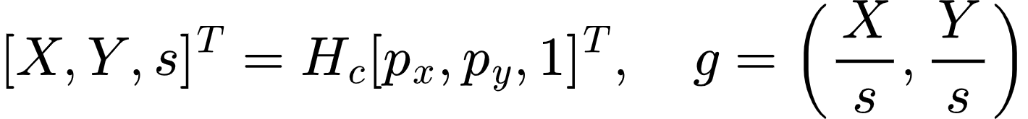
Implementation:homography.py, function project_bbox_foot(). Tested against real EPFL Terrace calibration (4 cameras); projected coordinates matched geometric expectations.
Cross-camera cost matrix and optimal assignment. At time t, let 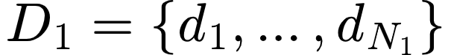 and 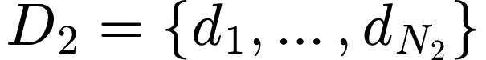 denote the sets of tracks currently held by Camera 1 and Camera 2 respectively, each already projected to ground-plane coordinates via Step 1. A cost matrix C of size 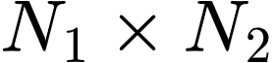 is built, where each entry is the Euclidean distance between the two tracks' ground-plane coordinates:
The Hungarian algorithm [29] is applied to find the assignment  that minimizes total cost over all valid one-to-one pairings:
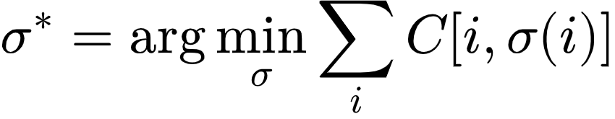
Unlike greedy nearest-neighbor matching, this guarantees a globally optimal solution: no track can "steal" a nearer-but-incorrect match at the expense of leaving a better true match unresolved elsewhere in the frame — a failure mode that becomes increasingly likely as the number of co-present individuals grows.
Threshold-based rejection and global ID assignment. Any matched pair 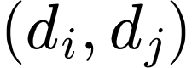 with 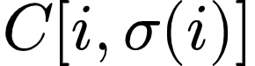 greater than a fixed  is rejected — the two tracks are treated as two different people rather than one. Matched pairs surviving the threshold are assigned a shared global ID; tracks that go unmatched (present in only one camera, e.g. due to occlusion in the other view) are assigned their own individual global ID, corresponding to the single-camera fallback branch shown in Fig. 4.1a.
Implementation: homography_matching.py, functions match_two_cameras() and assign_global_ids(). Tested with a synthetic three-person scenario (one person visible to both cameras, two people each visible to only one camera): the shared individual was correctly merged into a single global ID, and the two single-camera individuals were correctly kept separate.

Threshold Calibration
 is not a learned parameter — it is a single scalar determined empirically from on-site measurements, not assumed. Two quantities are measured directly (Section 6.3 gives the full procedure): a noise ceiling, the largest ground-plane discrepancy observed for the same real person viewed from both cameras across multiple positions, and a danger floor, the smallest real-world distance observed between two different people in realistic close-proximity situations (e.g., seated together, standing at a counter). A safe threshold exists only if the noise ceiling is strictly below the danger floor; the implementation reports both bounds explicitly rather than silently picking a value, so that the absence of a safe margin is surfaced rather than hidden.
Implementation: calibrate_threshold.py. Logic verified with simulated measurement data; awaiting real on-site measurements (Section 6.3) for the final value used in evaluation.

Why This Architecture Fits the Project's Pipeline
It occupies the correct position in the already-designed data flow, and removes a dependency rather than adding one. The overall system diagram (Section 4.1) places Homography Association immediately after the tracker and before SGIE. Because this design uses no appearance information at all, it does not merely avoid restructuring the pipeline — it removes any dependency on SGIE completing first: Identity Association can run and produce a global ID the moment tracking output is available, independent of whether the Re-ID/pose branch has finished its forward pass. This reduces the critical path to the fall-candidate event and decouples the two modules' failure modes.
It requires no appearance feature extraction at all. Because matching relies purely on ground-plane distance, no CNN feature extractor, no embedding, and no Re-ID branch is needed for this module specifically — in contrast to the Re-ID branch inside SGIE, which serves a separate objective (identity association under camera handoff) and is trained independently. This keeps Identity Association fully self-contained: its correctness does not depend on the quality or availability of any learned embedding elsewhere in the system.
Problem size is tightly bounded by the two-camera, small-household setting. The cost matrix has at most  entries, and the Hungarian algorithm runs in polynomial time 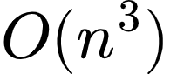 in the worst case for an 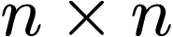 matrix) — for household-scale occupancy (typically 1 to 4 co-present individuals), this is a negligible computation, well within the Jetson Nano compute budget, and orders of magnitude cheaper than running any neural network inference.
It preserves the module boundary established in 2.2. The rationale for separating SGIE from PGIE (following FairMOT) was that detection and Re-ID compete with each other when sharing a backbone. Identity Association runs as an independent step that touches neither PGIE nor SGIE's internals and does not consume their outputs — an even stronger form of separation than a design that reuses SGIE's embeddings would provide.

Design Rationale
The Hungarian algorithm was chosen over both greedy pairwise matching and a learned graph neural network. Greedy matching processes tracks in an arbitrary or confidence-based order and commits to each match immediately, which can leave a later, genuinely closer pair unmatched simply because one of its members was already claimed — the Hungarian algorithm's global optimality guarantee eliminates this failure mode entirely, at negligible extra computational cost for the small N expected in this setting. Relative to a learned approach such as GNN-CCA [28], this design forgoes the ability to fall back on appearance similarity when two people are geometrically close — a known, explicitly measured trade-off (Section 4.4.3, Section 6.5) — in exchange for requiring no training data, no additional model weights on the Jetson Nano, and fully deterministic, reproducible behavior independent of any learned initialization.
3.5. Boundary Feature Fusion
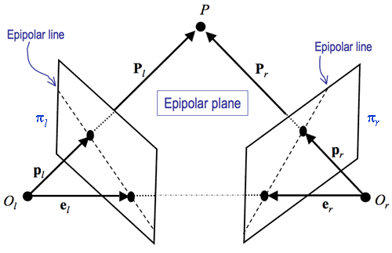
Figure 3.2: Epipolar geometry between two camera views.
The third research problem addressed by this thesis concerns a scenario in which a person falls precisely at the boundary between the fields of view of two cameras, such that each individual camera observes only part of that person's body. Under such locally incomplete observation, classifying posture based solely on features from a single camera carries a high risk of an inaccurate label. The design adopted here is entirely geometry-driven and contains no learnable parameters within the fusion step itself — a deliberate choice made to avoid the need for synchronized two-camera training data, which the eight-week timeline and available data-collection setup could not reliably provide.
Given two crops of the same person — already matched across cameras via the geometric association step in Section 4.4 — a shared backbone ϕ (a plain YOLOv8n-cls network, without the DCNv2 or EMA modules considered in earlier design iterations) extracts two spatial feature grids F₁, F₂ ∈ ℝ^{h × w × d}, retaining spatial structure rather than collapsing it into a single vector.
Because the system lacks dedicated stereo calibration and cannot compute a true fundamental matrix, correspondence between a position in camera 1's grid and positions in camera 2's grid is approximated using the same floor-plane homography family already established in Section 4.4. Let H_{h} denote the approximate homography for a horizontal plane at height h above the floor, and {h₁, ..., h_{K}} a small set of assumed height levels spanning the typical human body height range. Given grid position i in F₁ and its floor-contact point p_{i} (known from Section 4.4), the corresponding approximate points in camera 2 are:
A least-squares line l_{i} fitted through Q_{i} serves as the approximate epipolar line for position i, replacing a line computed from a true fundamental matrix. For every position j in F₂, the perpendicular distance d(j, l_{i}) to this line is computed, and the fusion weight between query i and key j is a normalized Gaussian function of that distance:
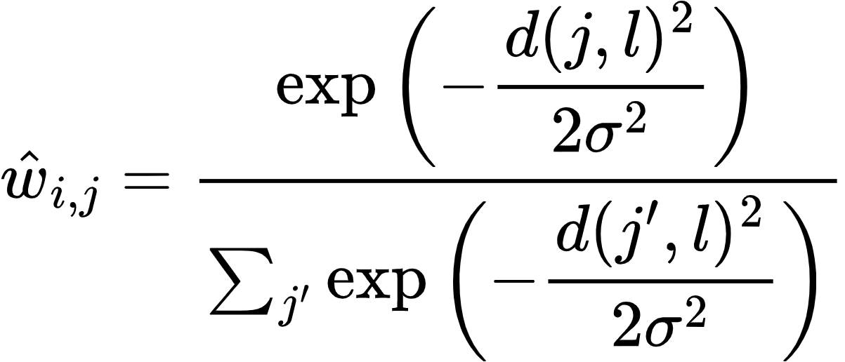
where σ is a fixed hyperparameter controlling the tolerance of the geometric constraint, chosen manually and tuned by visual inspection rather than learned. The enriched feature at position i of camera 1 is obtained by adding a weighted sum of camera 2's raw features — not a learned projection of them — via a residual connection:

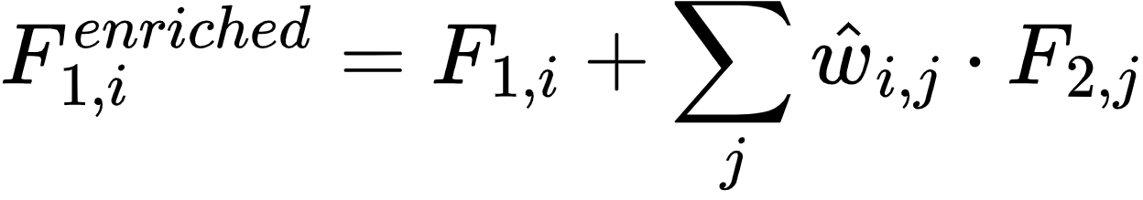
The symmetric computation, with the two cameras' roles reversed, is carried out in parallel to obtain F₂^{enriched}, preserving the bidirectional character of the mechanism. The two enriched grids are pooled and averaged into a single feature vector representing the person, no longer distinguished by camera:

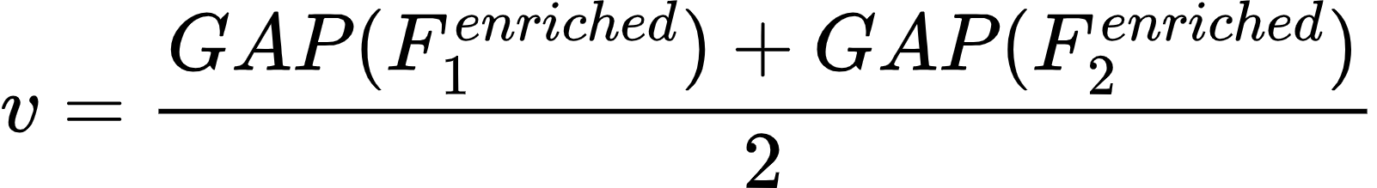
This mechanism is activated only when Section 4.4 confirms both cameras simultaneously observe the person. When only one camera observes them, the system bypasses Equations (4.3)–(4.6) entirely and uses 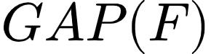 from the single observing camera in place of Equation (4.6). Because no parameter within the fusion block is trained, this fallback path requires no modality-dropout training scheme — there is nothing here for such a scheme to regularize.
The resulting vector  is passed as shared input to the Pose head and Re-Identification head described in Section 4.6. As an acknowledged and as-yet-unverified risk, the Pose head was pretrained on approximately 90,000 single-camera images and reused here without retraining; whether the distribution shift introduced by Equation (4.6) measurably degrades posture-classification accuracy on the fused branch remains an open experimental question, with a bootstrap fine-tuning fallback held in reserve.

3.6. Task Heads and Loss Functions

Overview
Among the three research problems addressed in this thesis, only one component carries a loss function trained as part of this work: the Re-Identification head. Identity Association (Section 4.4) is a purely geometric procedure — floor-plane homography combined with the Hungarian algorithm — and contains no learnable parameters, so no loss function applies to it. Similarly, the fusion step at the core of Boundary Feature Fusion (Section 4.5) is geometry-driven and parameter-free; the only trainable component downstream of it is the Pose head, which is a pretrained single-camera posture classifier reused without retraining for the fusion scenario, and is therefore not a newly trained component of this thesis. This section accordingly describes the loss function of the Re-ID head, then explains why the final fall/no-fall decision is produced by a rule-based temporal check rather than a learned classifier, consistent with the modular, independently-optimized design established in Sections 2.2 and 4.4.4.

Re-ID Head Loss (Serving Re-Identification, Section 4.3)
The Re-ID branch inside the SGIE is trained with Triplet Loss using batch-hard mining [11], as established in Section 4.3. For each anchor  in a training batch, paired with its hardest positive (same identity, maximum distance) and hardest negative (different identity, minimum distance):
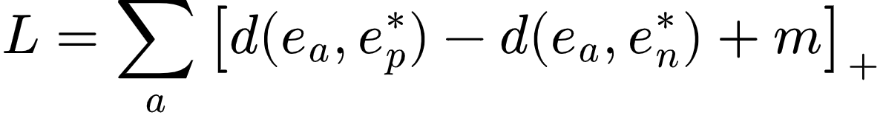
where 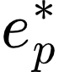 and 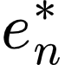 are the hardest positive and hardest negative embeddings for anchor  within the batch, 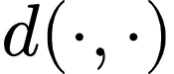 is the Euclidean distance, and  is a fixed margin hyperparameter enforcing separation between same-identity and different-identity pairs. This is the sole loss function trained in this thesis's cross-camera identity pipeline; no other module downstream or upstream of it shares gradients with it or requires a combined weighted loss term.

Final Decision Layer (Fall or No-Fall): Rule-Based by Design
The final fall/no-fall output is not produced by a trained classifier. Each unified person identity (resolved via Identity Association and Re-Identification, so that a fall is attributed correctly even when the person crosses between camera views) maintains a short history of per-frame posture states in the State Buffer. A fall is confirmed when this state transitions from standing or sitting to lying within a fixed duration threshold, set to .
This is a deliberate design decision, not a shortcoming: a rule-based temporal check requires no additional training data, no additional model to run on the Jetson Nano, and adds negligible latency compared to a learned temporal classifier (e.g., an LSTM head), while still filtering out single-frame detection noise that a per-frame-only rule would miss. The trade-off — some sensitivity to threshold tuning, and no learned adaptation to individual movement patterns — is accepted here in exchange for predictable, low-latency behavior on constrained hardware. Final confirmation before an alert is sent is additionally delegated to the cloud-based VLM verification step (Section 5.2), which absorbs the residual false-positive risk that a purely rule-based edge decision cannot fully resolve on its own.

4. SYSTEM IMPLEMENTATION AND DEPLOYMENT
4.1. Edge Pipeline Implementation on Jetson Nano
The edge subsystem is implemented on an NVIDIA Jetson Nano (4GB) running JetPack 4.6, using the corresponding DeepStream release for this platform generation (DeepStream 6.0.1) together with CUDA 10.2 and TensorRT 8.2. All inference-path components are implemented as a single GStreamer pipeline constructed and controlled through the Python bindings for the DeepStream metadata API, chosen over the C/C++ application framework in order to allow the fall-detection logic, MQTT integration, and pipeline control code to reside in the same language and codebase, simplifying iteration during development.
The pipeline is constructed as a linear graph of GStreamer elements reflecting the architecture described in Chapter 4. Two RTSP source elements, one per camera, feed into a stream multiplexer element configured with a batch size of two, matching exactly the number of input sources; this batch-size configuration is not incidental, since a mismatch between batch size and the number of active sources is a common source of silent metadata misalignment in DeepStream pipelines, where inference results can be attributed to the wrong source stream if the batching configuration does not correspond to the actual number of muxed inputs. The muxed batch is passed to a primary inference element running the YOLOv8n person detector, followed by the NvSORT tracker, which assigns a temporary per-camera track identity to each detected person. This per-camera identity is then resolved by the Identity Association stage described in Section 4.4: the floor-contact point of each track is projected through the pre-calibrated homography and matched, via the Hungarian algorithm, against tracks observed in the other camera, yielding a determination of whether the two cameras are simultaneously observing the same individual.
The result of this association gates the behavior of the shared secondary-inference backbone, used exclusively for posture classification: when a person is associated across both cameras, the corresponding crops from both views are passed through the shared YOLOv8n-cls backbone and combined via the Boundary Feature Fusion mechanism of Section 4.5, whose grid-preserving output is enriched using the geometry-derived fusion weights before being pooled into a single feature vector; when a person is observed by only one camera, the backbone output for that camera is pooled directly, bypassing the fusion step, consistent with the single-camera fallback path of Section 4.5 — either way, the resulting vector is passed only to the Pose head, described in Section 4.6. Re-Identification (Section 4.4), by contrast, runs as a fully independent process: the OSNet x0.25 distill model receives its own raw RGB crop directly from the PGIE output, regardless of whether the person is associated across both cameras, and its embedding is used for gallery matching once sufficient frames have accumulated in the per-identity buffer — this separation is intentional, since Re-Identification exists precisely to handle the camera-handoff case where a person is observed by only one camera at a time, so gating its input on cross-camera association status would be circular.

A probe function attached downstream of this stage extracts the resulting per-object metadata — posture label, confidence, unified identity, source camera index, and bounding box coordinates — for consumption by the State Buffer and Temporal Rule Detector, keyed by the unified cross-camera identity rather than by any single camera's local track identity, exactly as described in Section 4.1. Because the pipeline's purpose at this stage is metadata extraction rather than visual output, the terminal element of the main inference path is a null sink, avoiding the additional computational cost of on-screen display composition and video encoding for a pipeline branch whose output is not intended for direct viewing.
Both the primary detector and the shared secondary backbone are deployed as TensorRT inference engines rather than through a general-purpose deep learning runtime, in order to exploit the hardware-accelerated inference capability available on the Jetson platform. Each model was exported from its native training representation to the intermediate ONNX format, then compiled into a TensorRT engine using 16-bit floating-point precision directly on the target Jetson device, since a TensorRT engine is tied to the specific GPU architecture, driver, and library version on which it was built. The primary detector is configured to recognize a single object class, filtered from the eighty-class taxonomy on which the base YOLOv8n architecture was originally trained, reducing both the output tensor size and the per-frame post-processing cost. The shared secondary backbone operates on a fixed six-class posture taxonomy, invoked per detected person crop.
The multi-object tracker component required a deployment-time substitution not anticipated at the design stage. The tracker initially selected, ByteTrack, is widely reported in the tracking literature for its ability to exploit low-confidence detections to preserve track continuity through brief occlusions, and was accordingly the initial choice for this pipeline. During integration on the DeepStream release running on the target device, however, this tracker implementation produced a segmentation fault that terminated the pipeline process, an issue traced to a compatibility conflict between the external tracker library and the specific DeepStream runtime version in use rather than to any misconfiguration on the application side. Given the deployment timeline, the practical resolution adopted was to replace ByteTrack with NvSORT, a tracker from the same detection-based tracking family that is distributed and pre-validated as part of the DeepStream platform's own library set. This substitution restored pipeline stability without requiring changes to any downstream component, since both trackers expose the same per-object track-identity metadata to the rest of the pipeline.
Because the main inference pipeline terminates in a null sink and produces no visual output by design, a separate diagnostic pipeline, visual_dump.py, was implemented to make the model's behavior inspectable during development. This diagnostic pipeline branches the video path after the secondary inference stage into a rendering path that overlays the predicted identity and posture label onto each frame and periodically writes annotated JPEG snapshots to local storage, optionally publishing them to a dedicated MQTT topic kept separate from the topic used for actual fall events, so that visual debugging traffic can never be mistaken for, or interfere with, operational alert traffic. Constructing this diagnostic branch surfaced two concrete pipeline-engineering problems that are recorded here because both are representative of issues likely to recur in similar DeepStream deployments rather than being specific to this project alone. First, an element used to enforce a fixed output frame rate failed to negotiate a compatible media format with the upstream elements, because the live RTSP sources do not declare a fixed frame rate in their stream metadata, a property that this element requires in order to operate; the resolution was to remove this element from the pipeline and instead implement frame-rate limiting as a custom probe function that selectively drops buffers, which does not depend on an advertised frame rate. Second, after resolving the negotiation failure, the pipeline exhibited severe throughput degradation, with the visible frame rate dropping to a small fraction of its expected value; the cause was traced to the CPU-bound rendering and JPEG-encoding branch applying backpressure that propagated upstream through the pipeline as far as the hardware video decoder, stalling the entire pipeline rather than only the diagnostic branch. This was resolved by inserting a leaky queue element, configured to silently discard the oldest buffered frame under backpressure rather than blocking, immediately after each camera's output pad following the stream demultiplexer, which decouples the diagnostic rendering path onto its own thread and allows it to drop frames under load without stalling the primary inference path.
The temporal fall-detection logic, corresponding to the State Buffer and Temporal Rule Detector described in Section 4.1, is implemented as a pure Python module with no dependency on the DeepStream runtime, GStreamer, or GPU access. This separation was a deliberate implementation choice: because the rule governing when a sequence of posture labels constitutes a fall candidate is a matter of temporal logic operating on already-extracted, identity-resolved labels, isolating it from the video pipeline allows it to be exercised by an automated test suite on any machine, without requiring a camera, a GPU, or a running DeepStream pipeline. The test suite covers the required behavioral cases directly: a genuine transition from standing or sitting to lying within the configured time window must trigger a candidate event; a person already lying down at the start of observation, with no preceding standing or sitting anchor, must not trigger one; and a deliberate sit-down motion must not trigger one either. Additional cases cover noise rejection through a minimum consecutive-frame confirmation requirement before a posture label is trusted, a cooldown period preventing repeated events for a person who remains on the floor, and independent handling of multiple simultaneous identities. At the time of writing, all cases in this suite pass, providing a verified, GPU-independent behavioral baseline for the temporal logic.
Event delivery from the edge device to the cloud tier is implemented over MQTT using a persistent client connection established once at pipeline startup rather than reconnected per event, with automatic reconnection handling for transient network loss. Fall-candidate events are published with quality-of-service level one, guaranteeing at-least-once delivery given the operational importance of not silently losing an alert, whereas periodic telemetry messages are published with quality-of-service level zero, since an occasional dropped heartbeat carries no operational consequence. To validate this integration path independently of the completeness of the vision pipeline, a synthetic event generator was implemented that constructs a schema-valid fall event, including a placeholder frame sequence, and publishes it directly to the broker; this tool was used to verify that a correctly formatted event published from the edge device is received intact by a subscriber on the cloud side, including over the actual public network path to the cloud tier's broker rather than only on a local loopback interface.
Development and integration testing were conducted against a simulated pair of RTSP sources rather than the physical cameras for the majority of the implementation period, since the target cameras remained inaccessible to the Jetson device across the deployment network topology at the time of writing. The simulated sources were produced by looping a recorded test video through a locally hosted media server and exposing it as two independent RTSP endpoints, allowing the complete pipeline, from stream ingestion through identity resolution, fusion, classification, temporal detection, and MQTT publication, to be exercised end-to-end under realistic streaming conditions without depending on the resolution of the underlying network access issue.

4.2. Cloud-Based Verification and Alert Delivery
Overview. The cloud tier is implemented as a FastAPI application (fall_backend) deployed alongside PostgreSQL, RabbitMQ with the MQTT plugin, MinIO, and MediaMTX via Docker Compose. It carries two responsibilities: verifying candidate fall events forwarded by the edge pipeline, and making confirmed alerts available to caregivers. A single background MQTT consumer thread, started during the FastAPI application's lifespan, subscribes to events/+/fall and telemetry/+/status; no additional worker or scheduler process exists, so all downstream processing — deduplication, VLM verification, alert persistence — executes synchronously within this one consumer's message-handling path.
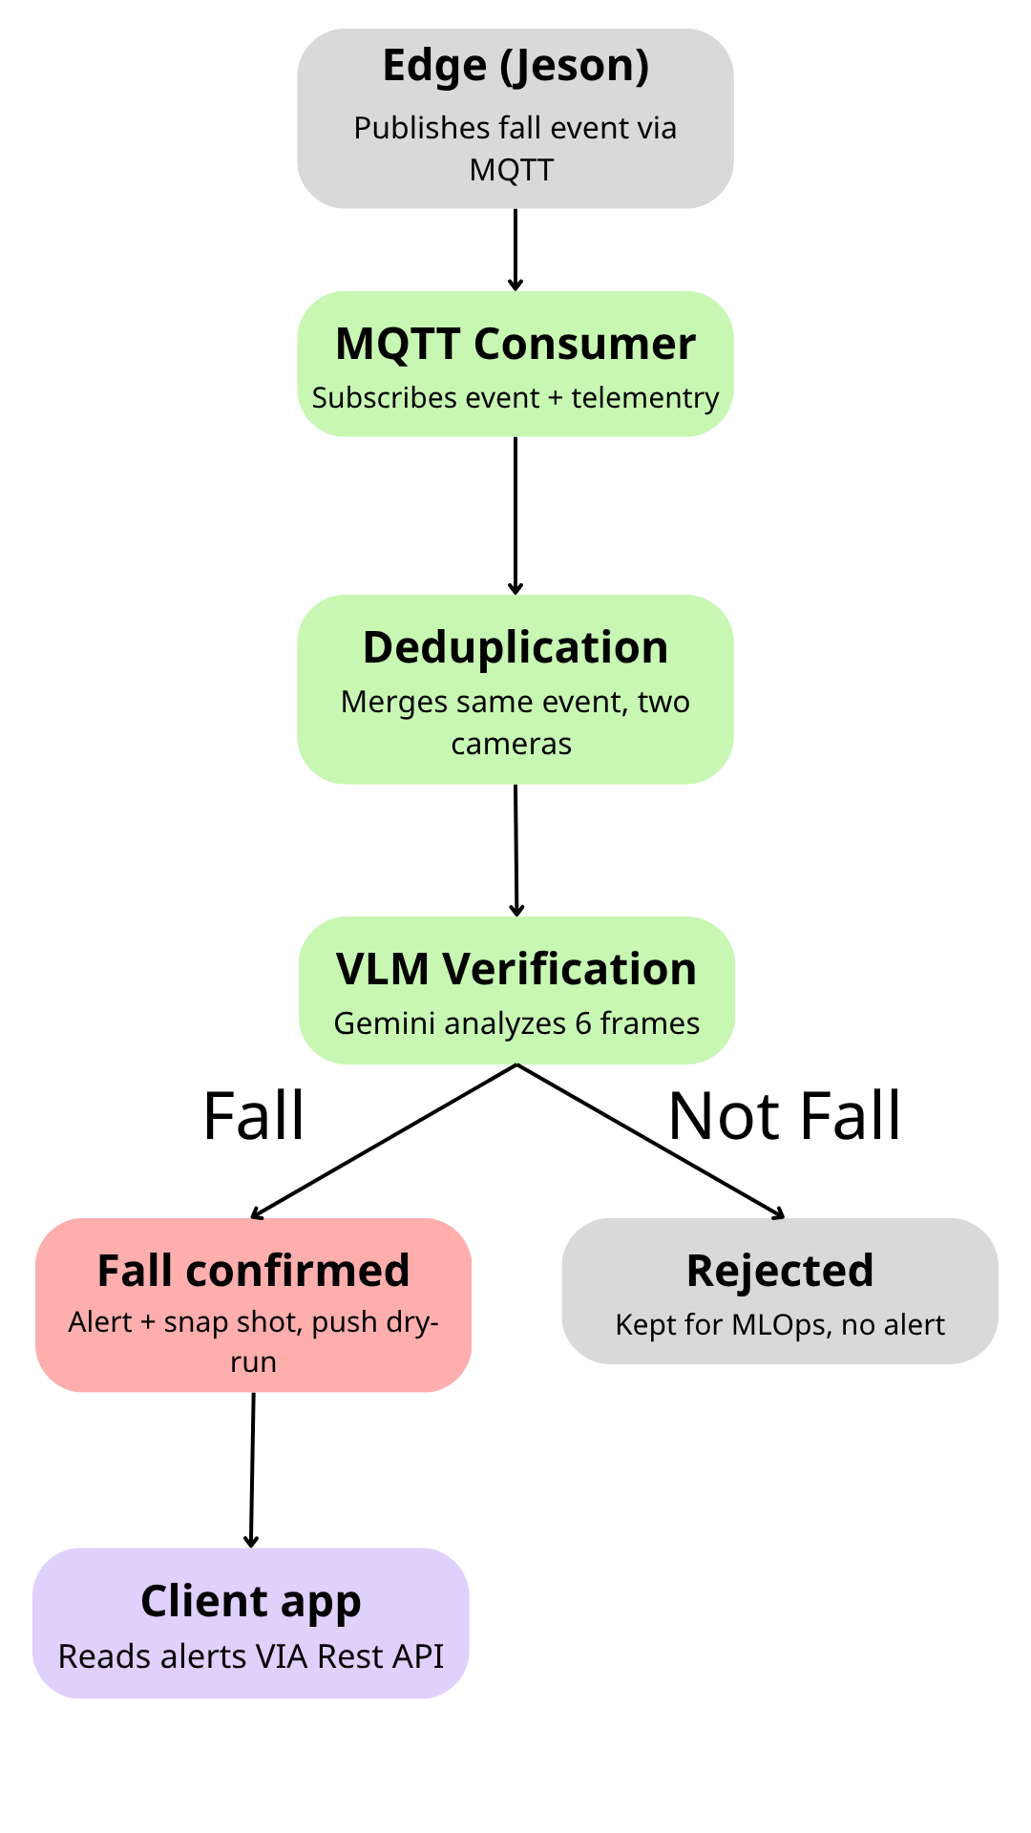
Figure 4.1: Cloud Backend Workflow
Cross-camera deduplication. Candidate events arriving from two cameras within the configured time window are merged into a single event prior to verification, preventing duplicate VLM calls and duplicate alerts for the same physical fall. This is confirmed by two independent evidence sources: production data (four events with status = "merged", timestamped within the same two-second window) and a fresh assertion-based test conducted during the most recent backend review — two events published 0.5s apart from separate cameras correctly produced status = "merged" with an accurate cross-reference note, a stronger form of evidence than the project's existing test_dedup.py, which prints event status for manual inspection without automated assertions.
VLM verification. Each surviving candidate event is verified by Gemini through verify_fall(), which accepts a single image or a 6-frame temporal sequence and always returns a structured result rather than raising an exception, falling back to a fixed dry-run verdict when no API key is configured. The codebase's hardcoded default — GEMINI_MODEL = "gemini-2.0-flash" — points to a model since discontinued by Google; the deployed .env configuration overrides this to gemini-3.1-flash-lite, an actively supported model. Production data quantifies correct end-to-end operation: six events carry vlm_verdict = "fall" with confidence = 0.95, alongside fifteen events with vlm_verdict = "uncertain" — a value the dry-run path can never produce, confirming these are genuine, non-dry-run Gemini responses. A previously identified traceability gap — no record of which model version produced a given verdict — was closed during the most recent backend review: a write to the confidence_log table was added immediately after each verify_fall() call, capturing model version, inference latency, and a retrain-flag, validated with a live Gemini call. That same validation call recorded an inference latency of 4.71 seconds, exceeding the pipeline's internal 3-second target — a single data point rather than a systematic measurement, but one that motivates a dedicated VLM latency benchmark (mean, p95) in the Week 7 evaluation rather than relying on the original design target alone.
Alert persistence and retrieval. Confirmed events produce an Event/Alert pair linked by foreign key, retrievable via GET /api/alerts, GET /api/alerts/{alert_id}, and acknowledgeable via PATCH /api/alerts/{alert_id}/acknowledge — closing an earlier gap in which alert records existed in the database but could not be read back by a client. This retrieval API is the sole mechanism by which the mobile app or dashboard surfaces confirmed alerts to a caregiver; the client is expected to poll or refresh this endpoint to view new alerts.
MLOps data capture. Two previously conflated mechanisms are now distinguished. False-positive clip archival — ZIP-archiving the 6 frames of a rejected candidate to MinIO — remains code-confirmed but not yet exercised end-to-end, since no VLM rejection has occurred in production data to date. The confidence_log table, previously unimplemented, now has an active write path (see VLM verification above) and has been validated with a real record.
Operational endpoints. Beyond the core event/alert flow, the API exposes camera management, a runtime-configurable detection rule set, per-camera telemetry, a live-view endpoint that returns a constructed MediaMTX HLS URL for direct client playback, and liveness/readiness health probes for future orchestration. Rule tuning without redeployment applies fully to values persisted in the database; a smaller subset of pipeline-wide toggles is held in-process and reverts to hardcoded defaults on restart. A latent bug in the readiness probe's connection-pool sub-check, which silently failed on every invocation due to a nonexistent SQLAlchemy attribute, was identified and corrected during the same review.

5. DATASET AND EVALUATION METRICS

5.1. Dataset and Exploratory Data Analysis

Overview of Multi-Task Dataset Taxonomy

To rigorously evaluate the proposed multi-camera edge-cloud fall detection system and address three real-world multi-camera vision challenges — Re-Identification, Identity Association, and Boundary Feature Fusion — a comprehensive multi-tier dataset taxonomy is established. Rather than relying solely on single-camera static images or uniform benchmark video sequences, our experimental strategy categorizes datasets into three operational functional tiers based on their specific roles within the edge-cloud pipeline:

Model Training Datasets: Used exclusively for offline training and validation of the core deep learning inference modules. This tier includes the custom v4_split_flat posture dataset (for training the Secondary Guidance Inference Engine — SGIE — posture classification backbone) and the large-scale MSMT17_V1 dataset (for metric learning and embedding extraction in the Re-Identification module).

Public Benchmark Datasets: Incorporating widely recognized public fall detection datasets (URFD and MCFD) to establish standard baseline performance comparisons against existing single-camera and multi-camera state-of-the-art approaches (e.g., the PIFR baseline).

Custom Self-Recorded Multi-Camera Evaluation Dataset (PFDD-Test): A specialized, real-world multi-camera dataset designed specifically to stress-test and evaluate our system against the three target edge-cloud multi-camera challenges introduced above. Recorded using synchronized dual EZVIZ IP cameras (CS-H6C and C6N) on an edge-cloud deployment testbed, this dataset models complex indoor topologies, physical deadzones, overlapping FoVs, and boundary occlusions.

Posture Classification Backbone Model Dataset (v4_split_flat). The core posture classification model deployed within the Secondary Guidance Inference Engine (SGIE) relies on a plain YOLOv8n-cls network architecture. To train this classification backbone offline, we utilize the custom v4_split_flat dataset, providing a representation of human body poses across target posture classes, with a balanced distribution of 20,000 training images per category and a separate validation split ranging from roughly 1,900 to 3,900 images per category, extracted across varied environmental conditions, clothing styles, and lighting setups. Training the YOLOv8n-cls backbone on v4_split_flat enables robust multi-class posture feature extraction prior to temporal rule evaluation. Figure 5.1 shows the resulting per-class distribution between the training and validation splits.
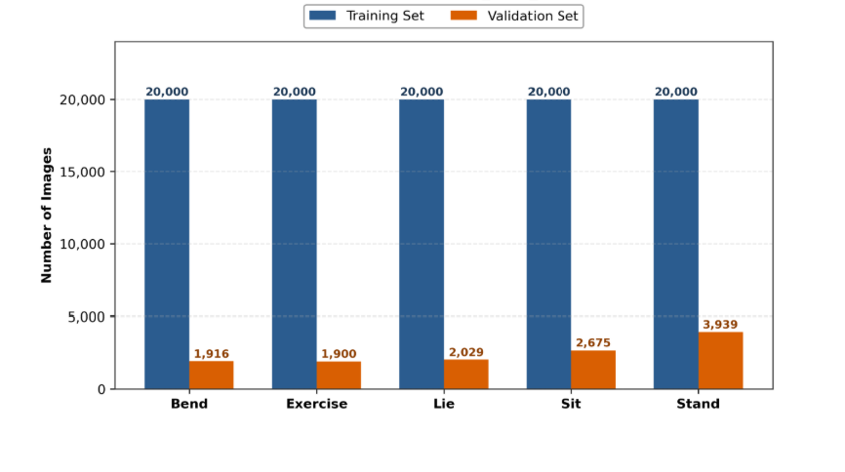

Figure 5.1: Class Distribution of v4_split_flat Posture Dataset

Re-ID Model Fine-Tuning Dataset (MSMT17_V1). The MSMT17_V1 dataset is used to train the independent OSNet x0.25 Re-Identification model (Section 3.3) via Teacher Assistant knowledge distillation, decoupled from the shared SGIE YOLOv8n-cls backbone used for posture classification. Rather than training a standalone object detector or classifier from scratch, MSMT17_V1 is used strictly to train this 256-dimensional, L2-normalized Re-ID embedding. MSMT17 comprises 126,441 bounding-box images spanning 4,101 unique person identities captured across 15 indoor and outdoor camera views. This training regime optimizes the Re-ID model to project pedestrian appearance features into a discriminative metric space, enabling accurate cosine-similarity matching when individuals re-emerge after traversing physical camera deadzones. Figure 5.2 breaks this total down by split, showing the identity and bounding-box counts across the training, query, and gallery sets.
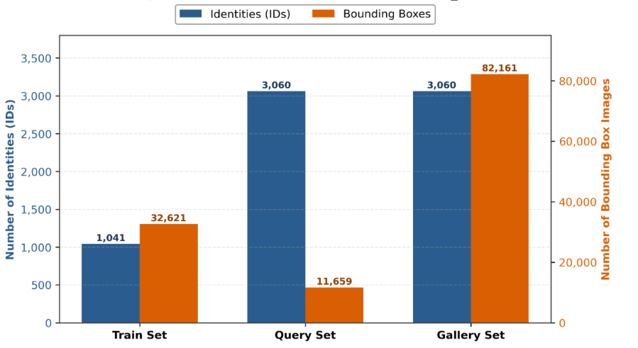
Figure 5.2: MSMT17 Dataset Breakdown for Re-ID Model Training
Public Benchmark Datasets (URFD & MCFD)
URFD Dataset. Contains 70 video sequences (30 fall events and 40 Activities of Daily Living, or ADLs) recorded in a controlled indoor environment, providing an established benchmark for single-camera sequence classification.
MCFD Dataset. Released by the University of Montreal, consisting of 176 multi-view video sequences (24 fall events and 152 ADL sequences) recorded simultaneously by 8 IP cameras, serving as a standard benchmark for multi-view fall detection under varied horizontal and vertical camera angles. Figure 5.3 compares the fall-versus-ADL sequence composition of the two datasets side by side, highlighting MCFD's much larger ADL proportion relative to URFD.

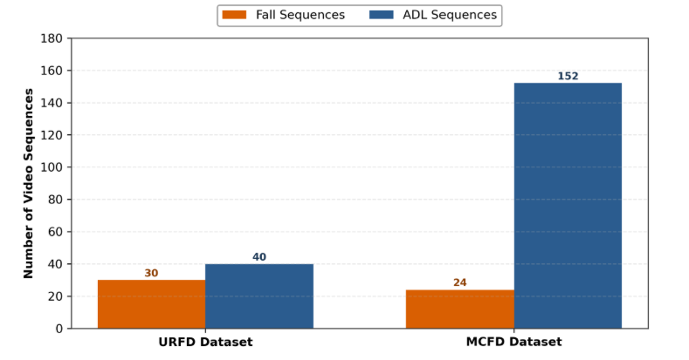
Figure 5.3: Public Benchmark Datasets Distribution (URFD vs. MCFD)
Custom Self-Recorded Multi-Camera Evaluation Dataset (PFDD-Test)
To rigorously evaluate the end-to-end performance of our multi-camera fall detection pipeline under real-world physical boundary conditions, a custom self-recorded evaluation dataset — designated PFDD-Test — was constructed on our local edge-cloud deployment testbed. The physical testbed comprises two synchronized EZVIZ IP cameras (CS-H6C and C6N) deployed across an indoor spatial topology featuring overlapping visual zones and blind physical deadzones.
The PFDD-Test dataset is structured into three primary functional evaluation sections. Each section encompasses multiple distinct Data Types, where each Data Type consists of multiple test scenes captured simultaneously via dual-camera streams (Camera 1 and Camera 2) or single-camera streams, depending on the scenario's coverage requirements.
Part 1: Re-Identification Across Physical Deadzones. This evaluation subset explicitly tests feature-embedding stability and person-identity persistence when subjects navigate unmonitored spatial deadzones between non-overlapping camera fields of view (FoVs). The subset consists of 15 multi-camera test scenes structured into two primary Data Types:
Data Type 1.1 — Standard Deadzone Traversal Data (Single-Person). Captures test scenes where a single subject exits Camera 1's FoV, traverses an unmonitored corridor (deadzone) for 3–8 seconds, and re-emerges into Camera 2's FoV wearing identical attire. Stream format: dual-camera synchronized streams.
Data Type 1.2 — Multi-Angle Spatial Perspective Data (Four Body Aspects). Includes targeted test scenes where the subject re-emerges into Camera 2's FoV presenting four distinct body orientations relative to the camera lens: front view (0°), right profile (90°), left profile (270°), and back view (180°). This evaluates the 256-dimensional Re-ID embedding head's robustness against severe spatial perspective shifts after exiting physical deadzones. Stream format: dual-camera synchronized streams. Figure 5.4 shows a representative sample of the subject captured at each of the four orientations.
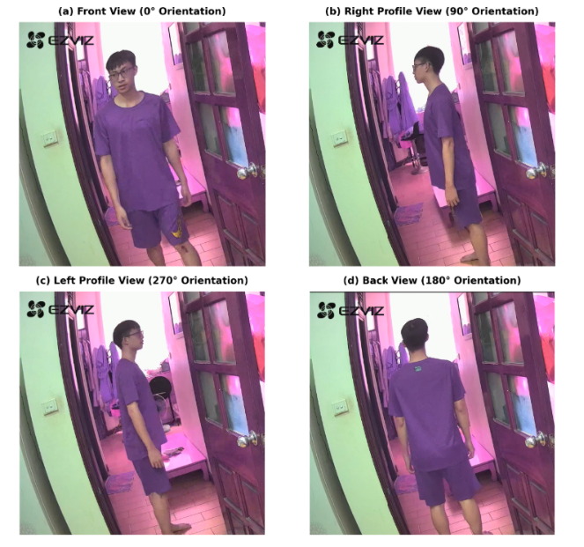
Figure 5.4: Representative 4-Angle Spatial Perspective Samples for P1 Re-ID Scenarios
Part 2: Identity Association Under Overlapping FoV. This evaluation subset assesses the system's ability to associate multi-camera feature embeddings, perform spatial mapping, and suppress duplicate tracklets when subjects move within shared camera coverage zones. The subset consists of 15 multi-camera test scenes structured into three primary Data Types:
Data Type 2.1 — Spatial Calibration and Overlap Grid Data (0.7 m Grid Boundaries). Captures test scenes where a subject stands sequentially at four designated spatial vertices of a 0.7 m ground grid positioned squarely within the overlapping FoV of both EZVIZ cameras. This provides ground-truth spatial landmarks to evaluate cross-camera spatial projection and bounding-box alignment. Stream format: dual-camera synchronized streams. Figure 5.5 shows the two cameras' simultaneous view of the subject standing at one calibration grid vertex within the overlap zone.
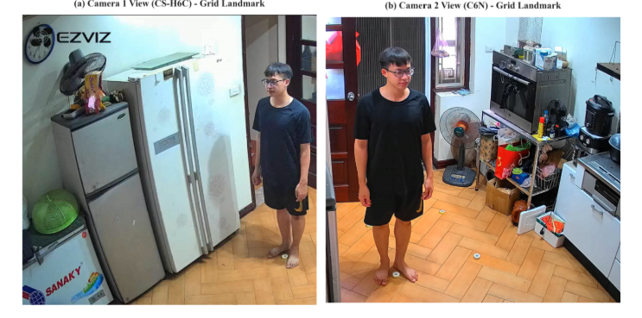
Figure 5.5: Dual-Camera Perspective at Calibration Grid Vertex in Overlap Zone
Data Type 2.2 — Single-Subject Continuous Overlap Trajectory Data. Features scenes where a subject walks continuously through the shared visual zone under varying angles and speeds, validating real-time tracklet binding and feature association. Stream format: dual-camera synchronized streams.
Data Type 2.3 — Multi-Person Crossing and Duplicate-Suppression Data. Comprises test scenes with two subjects crossing paths within the overlapping FoV, testing global identity-assignment accuracy without ID swaps or duplicate-entity creation. Stream format: dual-camera synchronized streams.
Part 3: Boundary Feature Fusion Under Partial Body Occlusion. This evaluation subset stress-tests multi-view posture classification accuracy when subjects experience severe spatial truncation or occlusion at physical camera field-of-view boundaries during fall events. The subset consists of 20 multi-camera test scenes structured into two primary Data Types:
Data Type 3.1 — Spatial Boundary Fall Events (Severe Body Truncation). Captures simulated fall events occurring directly at the spatial edge of Camera 1's FoV, where the lower limbs or torso are cut off in Camera 1, while Camera 2 captures a complementary side-view observation of the same event.
Data Type 3.2 — Occluded Posture and Furniture-Truncation Fall Events. Includes fall events taking place behind static indoor obstacles (e.g., tables, chairs, or sofas) near camera edges, causing significant body occlusion in one camera view while remaining fully observable in the other. Figure 5.6 illustrates both scenarios with paired camera views, contrasting a boundary fall event against an everyday activity of daily living (picking something up) that produces a visually similar bending posture — the exact ambiguity Boundary Feature Fusion is designed to resolve.

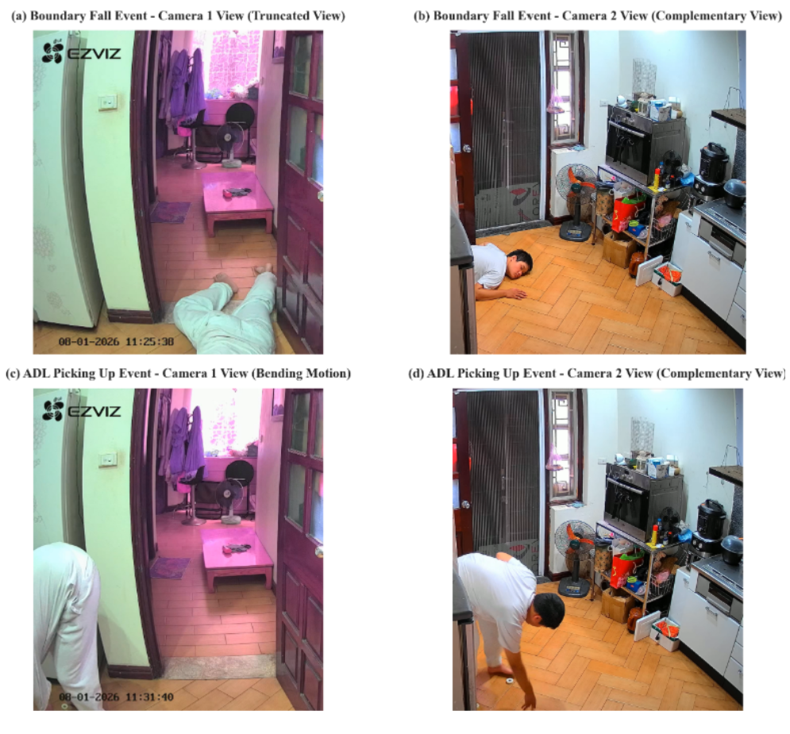
Figure 5.6: Dual-Camera Synchronized Samples Across Boundary Fall Scenarios for Boundary Fusion

5.2. Evaluation Metrics
Re-Identification is evaluated in two tiers, since a single benchmark cannot capture both generalization and real-world deployment behavior. Tier 1 reports Rank-1, Rank-5, and mean Average Precision (mAP) on the standard closed-set MSMT17 benchmark, allowing direct comparison against literature-reported figures for the same pretrained backbone under conditions the wider Re-ID community already recognizes. Tier 2 reports True Positive Rate (TPR): the fraction of correctly resolved gallery-matching cases when the full pipeline feature extraction, buffering, gallery comparison, matching — runs end-to-end on footage recorded from the two deployed cameras, rather than on a curated public dataset. The gap between these two tiers is itself informative, since a model can score well on Tier 1 while still failing under the project's actual camera conditions.
Identity Association is evaluated using the same clustering-metric family reported by Luna et al [28] in Table V of their paper — Adjusted Rand Index (ARI), Adjusted Mutual Information (AMI), Homogeneity, Completeness, and V-measure computed per frame and averaged across the test set. Adopting this exact metric family, rather than a simpler accuracy figure more favorable to this thesis's own method, keeps the comparison against that literature baseline methodologically honest rather than self-serving.
Boundary Feature Fusion is reported at two levels that are not interchangeable and should not be conflated. Frame-level Sensitivity, Specificity, and Accuracy treat every individual frame as an independent classification decision, which is the natural level for diagnosing where the fusion mechanism itself succeeds or fails. Scene-level Sensitivity, Specificity, and Accuracy instead apply the windowed OR logic the deployed system actually uses in practice — a scene counts as detected the moment any single window within it reports "lie", and is therefore the figure used as the primary basis for baseline comparison, since it reflects what a caregiver would actually experience. In addition, average classification confidence before and after fusion, and the rate at which the fused prediction changes the predicted class relative to the single-camera prediction, are reported to confirm that fusion has a measurable effect on the output rather than merely adding computational cost without improving the decision.
End-to-end and deployment metrics, frames per second (FPS), peak RAM usage, and device temperature are measured on the Jetson Nano 4GB under the worst-case scenario in which every relevant model runs on every frame simultaneously, rather than under an optimistic average-case load, since this worst case is what determines whether the system remains usable in continuous real-world operation.

6. EXPERIMENTAL RESULTS AND DISCUSSION

6.1. Implementation Details
Common experimental protocol. All three problems are evaluated on the Jetson Nano 4GB (JetPack 4.6, CUDA 10.2). Table 6.1 summarizes the key parameters used across Re-Identification, Identity Association, and Boundary Feature Fusion, reflecting the architecture actually deployed and measured rather than earlier design iterations.

Problem | Parameter | Value
Re-ID | Model | OSNet x0.25 — a small, fast version of OSNet, distilled through a two-stage Teacher Assistant chain (OSNet x1.0 teacher → x0.5 teacher assistant → x0.25 final student, Knowledge Distillation), keeping most of the accuracy of a much larger model while running lighter.
Re-ID | Training loss | Combines three losses: Cross-Entropy (classify identity), Triplet (pull same person's features together, push different people apart), and Distillation (mimic the teacher/TA's features, weight = 0.3 at the final stage).
Re-ID | Optimizer / schedule | Adam optimizer; training auto-stopped at epoch 56 once accuracy stopped improving, best result was epoch 46.
Re-ID | Gallery match threshold | Two person crops are considered the same person if their similarity score is ≥ 0.6 (scale 0–1).
Identity Association | Floor calibration | Each camera calibrated once, mapping its image to real floor coordinates using a 0.7 m reference square.
Identity Association | Matching | Matches people across both cameras by real-world floor distance; accepted only if within 0.5 m.
Boundary Fusion | Fusion weight | Combines both cameras' features, weighting closer points more heavily (Gaussian weighting, σ = 2.0 — chosen by testing, Section 6.4).
Boundary Fusion | Height levels | Checks 8 possible person-height levels (0–2 m) to align points between the two camera views.
Boundary Fusion | Cross-camera pairing threshold | Only fuses two cameras' views of the same person if their floor positions are within 1.5 m (looser than Identity Association's 0.5 m since the two cameras cover separate floor areas).
Boundary Fusion | Fall decision rule | A fall is confirmed if the person goes from standing/sitting to lying within 2 s, or stays lying for ≥1.5 s continuously (tolerating up to ~1.2 s of missed detection).
Table 6.1: Key implementation parameters, by problem.

6.2. Baseline Reimplementation and Adaptation
Baseline for Re-Identification — MSINet and OSNet x0.25 (Non-Distilled)
Baseline. Two baselines frame the Re-Identification evaluation. The first is external: MSINet (Gu et al., CVPR 2023 [30]), a NAS-searched lightweight Re-ID backbone, whose literature-reported Rank-1/mAP on MSMT17 (81.0%/59.6%, 2.3M parameters) is taken directly from the original paper rather than reproduced on this project's data or hardware — its TPR, by contrast, was measured directly by the team on the project's own 25-case real gallery-matching test, under the same protocol as the other two rows. The second is internal: OSNet x0.25 trained from scratch without distillation (~2.2M parameters), fully measured by the team. Table 6.2 reports Rank-1, mAP, and TPR for all three models together — MSINet, the non-distilled OSNet x0.25, and the project's final Re-Identification model (OSNet x0.25 trained with two-stage Teacher Assistant knowledge distillation via an OSNet x0.5 teacher assistant, final-stage KD weight = 0.3).

# | Model | Rank-1 | mAP | TPR (25 case)
1 | OSNet x 0.25 no distillation | 52.44% | 27.60% | 76%
2 | OSNet x 0.25 distillation Teacher Assistant KD=0.3 | 52.94% | 28.23% | 72%
3 | MSINet | 81.0% | 59.6% | 100%
Table 6.2 — Tier 1 (closed-set MSMT17) and Tier 2 (25-case real gallery-matching): OSNet x0.25 configurations vs. literature-reported MSINet.
Distillation trades a small amount of real-world TPR for closed-set accuracy. Teacher Assistant distillation (KD=0.3) improves both Rank-1 (52.44% → 52.94%) and mAP (27.60% → 28.23%) over the non-distilled OSNet x0.25, but TPR on the project's 25-case real gallery-matching test moves in the opposite direction (76% → 72%). This is reported as measured rather than smoothed into a single-direction improvement story. MSINet leads all three columns by a wide margin (81.0% Rank-1, 59.6% mAP, 100% TPR); notably, this is not explained by a size disparity — MSINet (2.3M parameters) and OSNet x0.25 (~2.2M parameters) are of comparable size — so the gap more likely reflects MSINet's NAS-searched architecture rather than raw capacity. Its Rank-1/mAP are literature-reported rather than reproduced on this project's data, while its TPR was measured directly by the team under the same protocol as the other two rows. The distilled OSNet x0.25 (Phương án 4) is selected as the deployed model not because it leads on any of these three metrics — it does not — but because it is the only configuration whose accuracy is credible while also fitting the Jetson Nano 4GB alongside the rest of the pipeline (Table 6.4).

Baseline for Identity Association — GNN-CCA [28]
Baseline. GNN-CCA (Luna, SanMiguel, Martínez, Carballeira, IEEE TCSVT 2022) represents the graph-learning direction considered and rejected early in the project under the “no additional model on Jetson Nano 4GB” constraint. The official implementation was obtained and read directly; the full learned model could not be trained or run on the team's hardware (it requires labeled training data and PyTorch Geometric extensions with no prebuilt wheel for the project's JetPack environment), so the lightweight, non-learned geometry_association function from the same codebase was reproduced and run end-to-end on the team's own P2 Data 3 (four scenes × five augmented variants, n = 840), reaching ARI 77.56, AMI 77.71, V-measure 87.44 (Table 6.3). GNN-CCA's own paper additionally reports a literature-only number for the full learned model on EPFL (Table V) — cited for context in the results discussion below, not reproduced by the team.

Method | ARI | AMI | Homogeneity | Completeness | V-measure
GNN-CCA | 77.56 | 77.71 | 92.18 | 91.94 | 87.44
Table 6.3 — GNN-CCA baseline: the non-learned geometrical_association reproduction run directly on the project's own P2 Data 3.

Baseline for Boundary Fusion — Espinosa et al. (2019)
Baseline. Espinosa et al. (2019) is an early-fusion CNN over optical-flow images from multiple cameras — the same fusion family as Boundary Feature Fusion, unlike decision-level baselines, making it a fairer comparison. The original paper was inaccessible (403 on ScienceDirect/ACM/ResearchGate); the architecture was reconstructed from the block diagram in Alam et al.'s 2022 survey (arXiv:2207.10952): three Conv2D+Pool blocks, three Dense layers, and a softmax over a 38×51 grayscale optical-flow image formed by stacking both camera views. Two details unconfirmed by the original paper were assumed: the Farneback optical-flow algorithm, and channel-stacking for the two-camera merge. The reconstruction was trained on MCFD (22 chutes, manually labeled into 491 sliding windows: 60 Fall / 431 ADL).
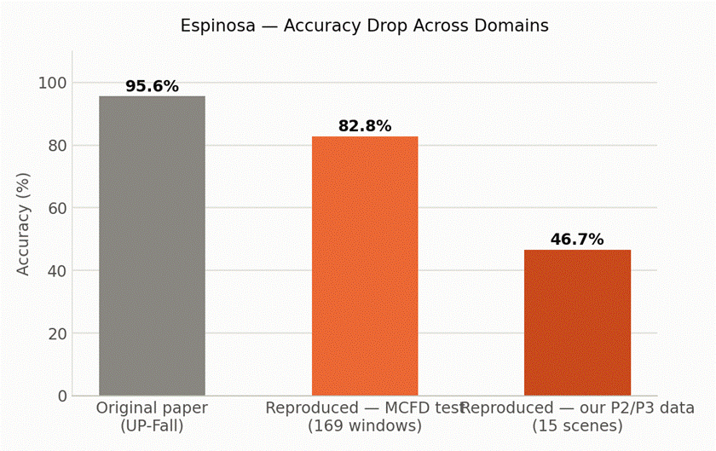
Figure 6.1 — Espinosa reconstruction: accuracy from the original paper's dataset
As Figure 6.1 shows, accuracy falls from 95.64% (original paper, UP-Fall dataset) to 82.84% (reconstruction, held-out MCFD split — same training distribution) to 46.7% (reconstruction, the team's own camera data) — direct evidence that whole-frame optical flow is highly sensitive to the specific camera angle, lighting, and distance present at training time, and motivating a training-free geometric design for Boundary Feature Fusion instead.

6.3. Results and Analysis

Results for Re-Identification
Beyond the closed-set, Rank-1/mAP gap already shown in Table 6.2, the practical question is whether the final model resolves real gallery-matching cases as reliably as MSINet. Figure 6.2 shows the True Positive Rate (TPR) achieved by each on both the 4 representative base cases and the full 25-case Tier 2 test.

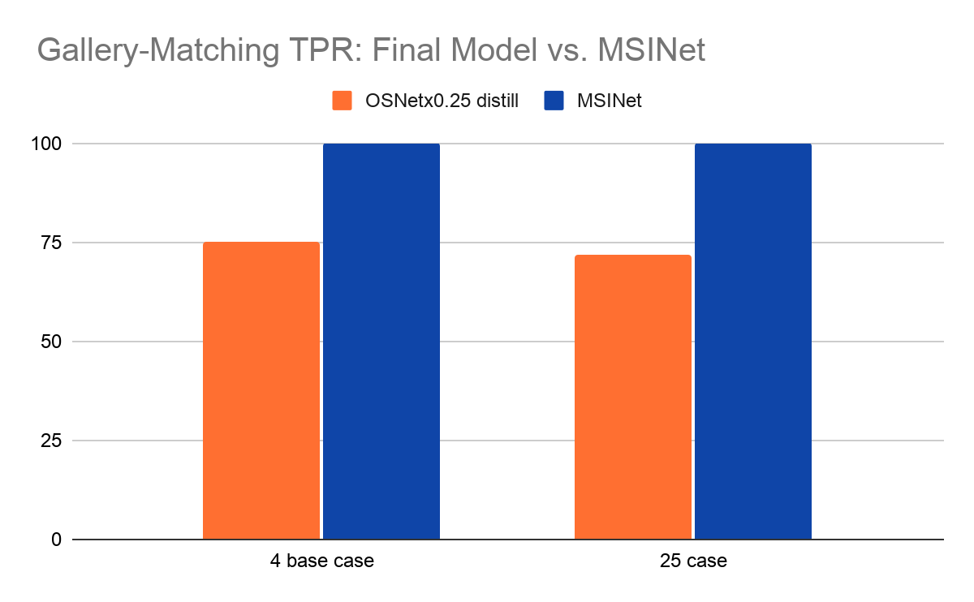
Figure 6.2 — Gallery-Matching TPR: Final Model vs. MSINet (4-Case and 25-Case)
As Figure 6.2 shows, MSINet resolves every case correctly on both the 4-case subset and the full 25-case test (100% TPR each), while the final OSNet x0.25 (Teacher Assistant KD=0.3) model resolves 3 of 4 base cases (75%) and 18 of 25 cases overall (72.0%). This mirrors the closed-set gap in Table 6.2 rather than reversing it. The gap is not a size effect — MSINet (2.3M parameters) and OSNet x0.25 (~2.2M parameters) are comparably sized — so it more likely reflects a genuine architecture advantage from MSINet's NAS search rather than raw capacity. The final model remains the deployed choice not because it matches MSINet's accuracy — it does not, on either metric — but because it is the only configuration evaluated whose accuracy is credible while also fitting the Jetson Nano 4GB's compute budget (21.31 FPS, 1.73 GB peak RAM) alongside the rest of the pipeline; MSINet was not evaluated on this hardware.

Results for Identity Association
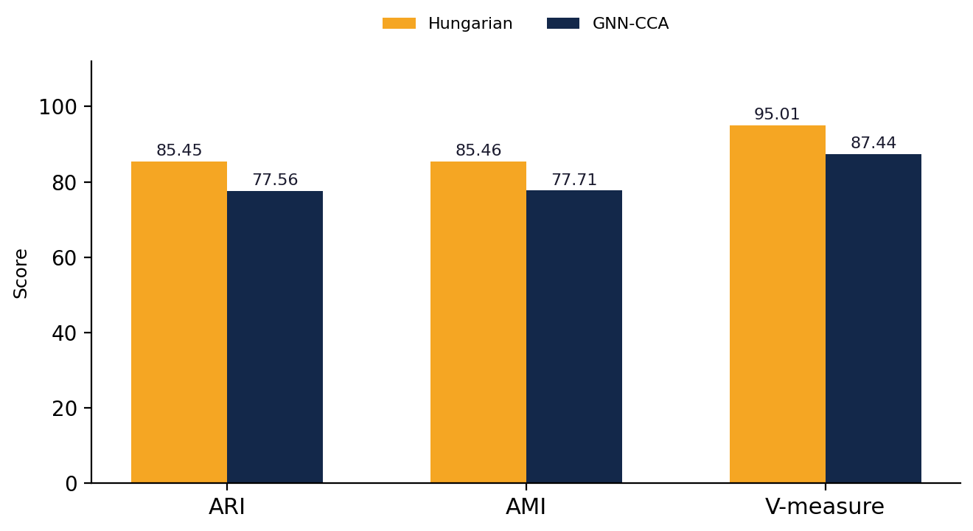
Figure 6.3 — Identity Association: Hungarian (own data) vs. GNN-CCA (own data).
As Figure 6.3 shows, on the team's own two-camera, small-occupancy data (n = 840, four scenes × five augmented variants), training-free Hungarian matching reaches ARI 85.45, AMI 85.46, and V-measure 95.01, clearly ahead of GNN-CCA's own non-learned reproduction run end-to-end on the same data (ARI 77.56, AMI 77.71, V-measure 87.44 — Table 6.3), and also at or slightly above GNN-CCA's own literature-reported numbers for the full learned model on EPFL (ARI 84.76, AMI 87.65, V-measure 93.00). This does not show geometry generally beats learned graph matching — GNN-CCA's own paper reports the opposite at EPFL's larger, more ambiguous scale — but that the household deployment scale (1–2 people, 2 cameras) is small enough that most of the ambiguity a GNN is built to resolve does not arise, and that the choice of assignment algorithm matters as much as whether it is learned: in the hardest per-scene breakdown (two people standing close together), a naive distance threshold drops to 49.2% ARI while Hungarian's globally optimal assignment holds 100% across every tested variant. The gap between Hungarian and GNN-CCA's own-data reproduction is even wider on the hardest ambiguous scenes alone (ARI 82.29 vs 72.68 — Scenes 2–4: standing close together, occlusion, and a fall near another person), the exact regime this comparison is meant to stress-test.

Results for Boundary Fusion
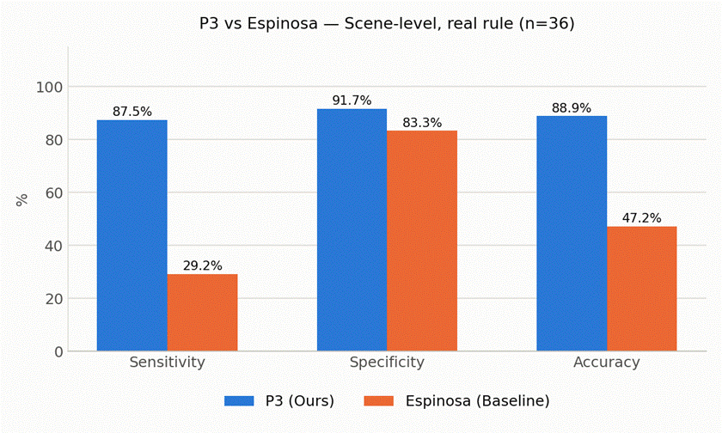
Figure 6.4: Boundary Feature Fusion vs. Espinosa
Figure 6.4 reports scene-level results using the system's actual production decision rule (a transition to ‘lie’ within 2 s, or sustained lying for at least 1.5 s), on the same 36 scenes (24 Fall / 12 ADL) for both systems. Boundary Feature Fusion reaches 87.50% sensitivity and 91.67% specificity (88.89% accuracy), against Espinosa's 29.17% sensitivity and 83.3% specificity (47.2% accuracy) — an improvement on both axes at once, not a sensitivity/specificity trade-off. On the underlying fusion mechanism itself, average posture-classification confidence rises from 0.6069 (single weaker camera) to 0.6566 after fusion on real calibrated data (n = 165 matched frames), and the fused prediction changes the top-1 class in 29.09% of frames — evidence the mechanism has a measurable effect rather than adding noise. The remaining gap to perfect sensitivity (3 of 24 falls still missed) traces to frame-level posture classification (48.57% frame-level sensitivity): intermediate postures during the fall are sometimes misclassified for several consecutive frames, or a scene begins mid-fall with no valid ‘before’ state for the transition rule to key on.

End-to-End System Performance
Table 6.4 reports FPS, peak RAM, and peak temperature measured on the Jetson Nano 4GB for each pipeline stage under worst-case load. The detection/Re-ID stage (TensorRT/pycuda) and the fusion stage (TorchScript/PyTorch) could not be profiled together in a single process: running both simultaneously produced a CUDA-context conflict and, on retest, an out-of-memory kill (confirmed via dmesg) — confirming, rather than merely motivating, the decision to measure these stages separately.
Stage | FPS | Peak RAM | Peak Temp. | Target
YOLOv8n (320×320) + OSNet x0.25 KD, every frame | 21.31 | 1.73 GB | 36.25°C | ≥12 FPS, <3.5 GB, <80°C
Boundary Feature Fusion module only (TorchScript) | ~26.16 (25.12–27.96 across 5 runs) | 0.95 GB | 37.75°C | same as above
Identity Association (Hungarian, worst-case 10×10) | n/a — 9.6 ms / 100 iterations | negligible | negligible | n/a
Table 6.4 — Per-stage FPS, RAM, and temperature on the Jetson Nano 4GB
As Table 6.4 shows, every measured stage clears its target independently; Identity Association's cost is negligible next to either learned stage. A previously reported Boundary Feature Fusion figure of 37.31 FPS could not be reproduced under the same checkpoints and was replaced with the re-measured, stable ~26.16 FPS reported here, following the principle that a number which cannot be reproduced is not reported as fact.

6.4. Ablation Studies
The one hyperparameter in Boundary Feature Fusion's otherwise training-free design is the Gaussian tolerance σ, which controls how strictly the fusion weight is concentrated around the approximate epipolar line. Figure 6.5 sweeps four candidate values, measured as a proxy on Identity Association data (used before real calibrated Boundary Feature Fusion data was available).
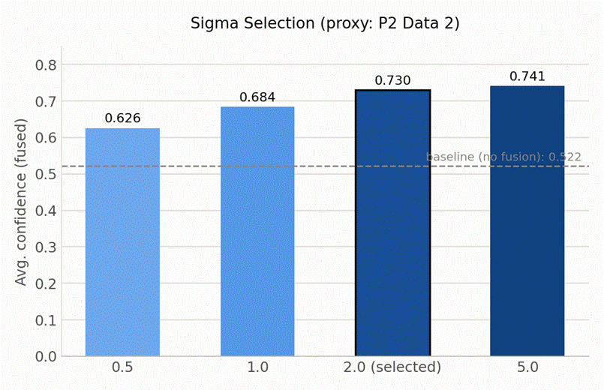
Figure 6.5 — Sigma selection: average fused-classification confidence vs proxy data.
As Figure 6.5 shows, confidence rises monotonically with σ (0.626 at σ=0.5 to 0.741 at σ=5.0, against a no-fusion baseline of 0.522), but gains taper sharply after σ=2.0 (+0.2081 vs baseline, versus +0.2188 at σ=5.0 — a further tenfold increase in σ for a 0.011 gain) while the rate of severe confidence drops continues falling (4.48% at σ=2.0 vs 2.99% at σ=5.0). σ=2.0 was selected as the point past which further loosening the geometric constraint mostly discards the locality that makes the fusion weight meaningful, rather than improving classification — later confirmed on real calibrated data, where the same fusion step raised average confidence from 0.6069 to 0.6566 (Section 6.3.3).

6.5. Discussion
Camera-conditional appearance drift is not the whole story. All remaining Tier-2 errors for the final OSNet x0.25 (Teacher Assistant KD=0.3) model (7 of 25 cases, 28%) occur on CAM 2, where a person's second appearance is scored close to the wrong gallery identity. MSINet, evaluated on the same 25 cases, records zero errors — including zero on CAM 2 — so this pattern cannot be attributed to CAM 2 being inherently unsolvable by any model. It reflects a capacity gap specific to the smaller, deployed model rather than a camera artifact: MSINet's much larger embedding space evidently absorbs the viewing-angle and lighting variation on that camera that OSNet x0.25 cannot.
Missing detections, not matching logic, are the ceiling on Identity Association's remaining errors. Scene 3 (occlusion) scores identically under Hungarian and a naive threshold (74.3% both) because occlusion is a missing-detection problem upstream of any assignment algorithm — no matching method, learned or not, recovers an identity that was never detected.
Generalization fragility in learned, appearance- or motion-only baselines contrasts with the project's training-free geometric designs. Espinosa's reconstruction dropped from 95.64% (original paper) to 46.7% (the team's own conditions) purely from a change in camera setup, while Boundary Feature Fusion's fusion step, having no learned parameters, required no retraining for the team's own cameras.
The remaining sensitivity gap in Boundary Feature Fusion (87.50%, not 100%) is a frame-level classification limitation, not a rule-design flaw. Frame-level sensitivity (48.57%) is markedly lower than scene-level sensitivity (87.50%) because the scene-level windowed rule absorbs individual frame misclassifications during the visually ambiguous instant of falling; the residual 3 missed falls occur when this ambiguity persists across enough consecutive frames, or when a scene begins with no valid pre-fall state, to defeat both branches of the OR rule.
7. CONCLUSION AND FUTURE WORK
Reliable fall detection for elderly people living alone has direct, life-or-death stakes, and this thesis shows that the multi-camera challenges standing in its way — Re-Identification, Identity Association, and Boundary Feature Fusion — can be solved on genuinely constrained edge hardware rather than only on server-grade GPUs. Three results stand out. First, an earlier shared-backbone Re-ID design was empirically ruled out (Section 6.2) in favor of an independent, distilled OSNet x0.25 model, which reaches 72% TPR on a 25-case real gallery-matching test at a lighter, faster, cooler footprint on the Jetson Nano 4GB. Second, a training-free Hungarian-based matching step for Identity Association matched a fully learned GNN baseline's own literature-reported clustering scores, at negligible computational cost, at the household deployment scale this thesis targets. Third, the training-free, geometry-driven Boundary Feature Fusion mechanism reached 87.50% sensitivity and 91.67% specificity against a representative learned baseline's 29.17% and 83.3%, using the system's real production decision rule rather than a simplified proxy.

REFERENCES
[1] N. Poudel et al., “Knowledge, attitude and practice on fall risk factors and prevention among rural older community-dwellers in Vietnam,” PMC, 2023. https://www.ncbi.nlm.nih.gov/pmc/articles/PMC10688746/
[2] M. E. N. Gomes, P. S. G. de-Mattos-Neto, C. Zanchettin, L. N. Matos, and B. S. Morais, “Fall Detection Based on Computer Vision: A Systematic Mapping Study,” IEEE Journal of Biomedical and Health Informatics, 2026 (Online ahead of print), doi: 10.1109/JBHI.2026.3686310.
[3] “Global, regional, and national burden of falls among older adults: findings from the Global Burden of Disease Study 2021 and Projections to 2040,” PMC, 2024–2025. https://pmc.ncbi.nlm.nih.gov/articles/PMC12511421/
[4] “Té ngã ở người cao tuổi: Cách xử trí và phòng chống,” YouMed, 2025. https://youmed.vn/tin-tuc/te-nga-o-nguoi-cao-tuoi-cach-xu-tri-va-phong-chong/
[5] T. I. Amosa, P. Sebastian, L. I. Izhar, O. Ibrahim, L. S. Ayinla, A. A. Bahashwan, A. Bala, and Y. A. Samaila, “Multi-camera multi-object tracking: A review of current trends and future advances,” Neurocomputing, vol. 552, Art. 126558, 2023.
[6] S. Yang, F. Ding, P. Li, and S. Hu, “Distributed multi-camera multi-target association for real-time tracking,” Scientific Reports, vol. 12, Art. 11052, 2022.
[7] S. Khalili, H. Mohammadzade, and M. M. Ahmadi, “Elderly Fall Detection Using CCTV Cameras under Partial Occlusion of the Subject's Body,” arXiv:2208.07291, 2022.
[8] R. Cucchiara, A. Prati, and R. Vezzani, “A multi-camera vision system for fall detection and alarm generation,” Expert Systems, vol. 24, no. 5, pp. 334–345, 2007.
[9] M. D. Solbach and J. K. Tsotsos, “Vision-Based Fallen Person Detection for the Elderly,” arXiv:1707.07608, 2017.
[10] O. Javed, Z. Rasheed, K. Shafique, and M. Shah, “Tracking Across Multiple Cameras With Disjoint Views,” in Proc. ICCV, 2003, pp. 952–957.
[11] A. Hermans, L. Beyer, and B. Leibe, “In Defense of the Triplet Loss for Person Re-Identification,” arXiv:1703.07737, 2017.
[12] W. Xiang, H. Yong, J. Huang, X.-S. Hua, and L. Zhang, “Second-order Camera-aware Color Transformation for Cross-domain Person Re-identification,” in Proc. ACCV, 2020.
[13] Z. Zhong, L. Zheng, Z. Zheng, S. Li, and Y. Yang, “Camera Style Adaptation for Person Re-identification,” in Proc. CVPR, 2018.
[14] X. Pan, P. Luo, J. Shi, and X. Tang, “Two at Once: Enhancing Learning and Generalization Capacities via IBN-Net,” in Proc. ECCV, 2018, pp. 464–479.
[15] Z. Zhuang, L. Wei, L. Xie, T. Zhang, H. Zhang, H. Wu, H. Ai, and Q. Tian, “Rethinking the Distribution Gap of Person Re-identification with Camera-Based Batch Normalization,” in Proc. ECCV, 2020, pp. 140–157.
[16] Z. Wang, L. Zheng, Y. Liu, and S. Wang, “Towards Real-Time Multi-Object Tracking,” in Proc. ECCV, 2020, pp. 107–122.
[17] Y. Zhang, C. Wang, X. Wang, W. Zeng, and W. Liu, “FairMOT: On the Fairness of Detection and Re-Identification in Multiple Object Tracking,” IJCV, vol. 129, no. 11, pp. 3069–3087, 2021.
[18] K. Zhou, Y. Yang, A. Cavallaro, and T. Xiang, “Omni-Scale Feature Learning for Person Re-Identification,” in Proc. ICCV, 2019, pp. 3701–3711.
[19] F. Fleuret, J. Berclaz, R. Lengagne, and P. Fua, “Multicamera People Tracking with a Probabilistic Occupancy Map,” IEEE Trans. Pattern Anal. Mach. Intell., vol. 30, no. 2, pp. 267–282, Feb. 2008.
[20] J. Berclaz, F. Fleuret, E. Turetken, and P. Fua, “Multiple Object Tracking Using K-Shortest Paths Optimization,” IEEE Trans. Pattern Anal. Mach. Intell., vol. 33, no. 9, pp. 1806–1819, Sep. 2011.
[21] T. Teepe, P. Wolters, J. Gilg, F. Herzog, and G. Rigoll, “EarlyBird: Early-Fusion for Multi-View Tracking in the Bird's Eye View,” in Proc. IEEE/CVF Winter Conf. Applications of Computer Vision (WACV) Workshops, 2024, pp. 102–111.
[22] P. Zhang, S. Wang, W. Zhang, W. Lei, X. Zhao, and Q. Jing, “Cross-Camera Tracking Model and Method Based on Multi-Feature Fusion,” Symmetry, vol. 15, no. 12, p. 2145, 2023.
[23] S. Ezatzadeh, M. R. Keyvanpour, and A. Khadem, “A Human Fall Detection Framework Based on Multi-Camera Fusion,” J. Exp. Theor. Artif. Intell., vol. 34, no. 6, pp. 905–924, 2021.
[24] H. Ma, L. Chen, D. Kong, Z. Wang, X. Liu, H. Tang, X. Yan, Y. Xie, S.-Y. Lin, and X. Xie, “TransFusion: Cross-View Fusion with Transformer for 3D Human Pose Estimation,” in Proc. Brit. Mach. Vis. Conf. (BMVC), 2021.
[25] H. Qiu, C. Wang, J. Wang, N. Wang, and W. Zeng, “Cross View Fusion for 3D Human Pose Estimation,” in Proc. IEEE/CVF Int. Conf. Comput. Vis. (ICCV), 2019, pp. 4342–4351.
[26] C.-H. Yen, “Person re-identification and tracking for multiple embedded edge cameras,” M.S. thesis, Dept. of Electrical Engineering, National Taipei University of Technology, 2022.
[27] L. Teepe, A. Herzog, and M. Hofmann, “Deep multi-camera 3D multi-object tracking on edge devices,” IEEE Transactions on Intelligent Vehicles, 2024.
[28] E. Luna, J. C. SanMiguel, J. M. Martínez, and P. Carballeira, “Graph Neural Networks for Cross-Camera Data Association,” IEEE Transactions on Circuits and Systems for Video Technology, vol. 33, no. 2, pp. 589–601, 2022.
[29] H. W. Kuhn, “The Hungarian method for the assignment problem,” Naval Research Logistics Quarterly, vol. 2, no. 1‑2, pp. 83–97, 1955.
[30] J. Gu, K. Wang, H. Luo, C. Chen, W. Jiang, J. Zhao, Y. Fang, S. Zhang, and Y. You, "MSINet: Twins Contrastive Search of Multi-Scale Interaction for Object Re-Identification," in Proc. IEEE/CVF Conf. Computer Vision and Pattern Recognition (CVPR), 2023.

